### Online Collaborate

Developed By

Name: K Naveenraj Reg.No: S200040300164

# NIIT

**Online Collaborate**

Batch Code - S210167

Start Date - 11/11/20

End Date - 15/03/21

Name Of the Coordinator - Lopamudra Bera

Name Of the Developer - K Naveenraj

Date of Submission - 15.03.2020

**NIIT**

###### **CERTIFICATE**

This is to certify that this report, titled **Online Collaborate** embodies the original work done by **Mr.K Naveenraj**, in partial fullfillment of his course requirement at NIIT.

**Coordinator : LOPAMUDRA BERA**

### Acknowledgement

I would like to thank my mentor Lopamudra Bera and also the institute NIIT who helped me achieve this project on Online Collaborate. It helped me to do a lot on the research on the project and the environment.

I am really thankful for the staffs for helping me around in learning a lot of information during my learning process.

### Abstract

This project manages the entire process of Blogging website to help Bloggers and Users to use the site with ease.

Its also provides single window system to Blogger

who can showcase their ideas and skills in their respective fields or showcase their passion.

### Configuration

**Hardware**

Dell Insprion 15 (i5 processor),

16Gb RAM,

2TB Hard Disk.

**Operating System**

Windows 10 X64

**Software**

* Eclipse IDE
* Java
* Spring Boot
* Hibernate
* MySQL
* Visual Studio
* Angular
* Html
* SCSS
* Typescript
* jQuery

### TABLE OF CONTENTS

Chapter 1- Introduction

1.0 Aim

1.1 Objectives

Chapter 2- Project Requirement Specification

2.0 Literature Research

2.1 Statement of Requirements

Chapter 3- Project Analysis

3.0 Project Plan

3.1 System Architecture

3.2 Business Process Model

3.3 Software Requirement Specification

3.4 High Level Use Case Diagrams

Chapter 4- Project Design

4.0 Low Level Use Case Diagrams

4.1 User Interface Design

4.2 Systems Input and Output Design

4.3 Database Structure

4.4 Sample Code

Challenges

Observations

References

Appendix

## AIM

The main objective of the Online Blogging System is to manage the details of Blogs,Topic,Idea,Content,Entries. It manages all the information about Blogs, Views, Entries, Blogs. The project is totally built at administrative end and thus only the administrator is guaranteed the access.

### OBJECTIVES

Following are the objectives to be achieved through Online Collaboration Application

* User registration
* Profile Validation
* Activation/Approving
* Posting Blogs
* View Blogs
* Job Postings
* Recruitment

This objectives are to be automated which were previously done manually.

### STATEMENT OF REQUIREMENTS

PROJECT OBJECTIVES

|  |  |
| --- | --- |
| Title | Online Collaborate |
| Subtitle | Blog Management System |
| Author(s) | K Naveenraj |
| Author’s E-mail | naveenrajkrishnan@gmail.com |
| Author’s Phone | 9942543332 |
| Description | Blogging Website |
| Version | 1.01 |

**About Your Company**

Online Collaborate is a public collaboration website which provides a platform to connect with people to share their works.

**Need for Collaboration**

### It helps us problem-solve

### Collaboration brings people and organizations closer

### Collaboration helps people learn from each other

### It opens up new channels for communication

### Collaboration boosts morale across your organization

### It leads to higher retention rates

### Collaboration makes us more efficient workers

### PROJECT LIFE CYCLE MODEL

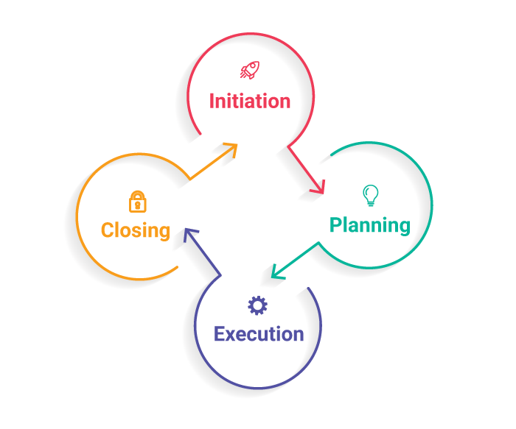

****The Initiation Phase:**** The initiation phase aims to define and authorize the project.

**Vision: Registration ,Authorization,Blogging**

****The Planning Phase:**** The purpose of this phase is to lay down a detailed strategy of how the project has to be performed and how to make it a success.

Strategic Planning- overall approach to the project

Implementation Planning-ways to apply the decisions

****The Execution Phase:**** In this phase, the decisions and activities defined during the planning phase are implemented.

****The Termination Phase:**** This is the last phase of any project, and it marks the official closure of the project.

### SYSTEM ARCHITECTURE

1. Tier Architecture
2. A ****Presentation Layer**** that sends content to browsers in the form of HTML/JS/CSS. This might leverage frameworks like React, Angular, Ember, Aurora, etc.
3. An ****Application Layer**** that uses an application server and processes the business logic for the application. This might be written in C#, Java, C++, Python, Ruby, etc.
4. A ****Data Layer**** which is a database management system that provides access to application data. This could be MSSQL, MySQL, Oracle, or PostgreSQL, Mongo, etc.

**Online Collaboration**

**Presentation Layer**

Home

**Angular Component**

(Login,Registration,User-list

Blog-List,Service)

ADMIN

USER





**JRE**

**DATABASE**

(Tables-User,Blog,BlogComments,)

Service

Controller

Configuration

CRUD OP

**Hibernate Config**

**Application Layer**  **Data Access Layer**

### BUSINESS PROCESS MODEL

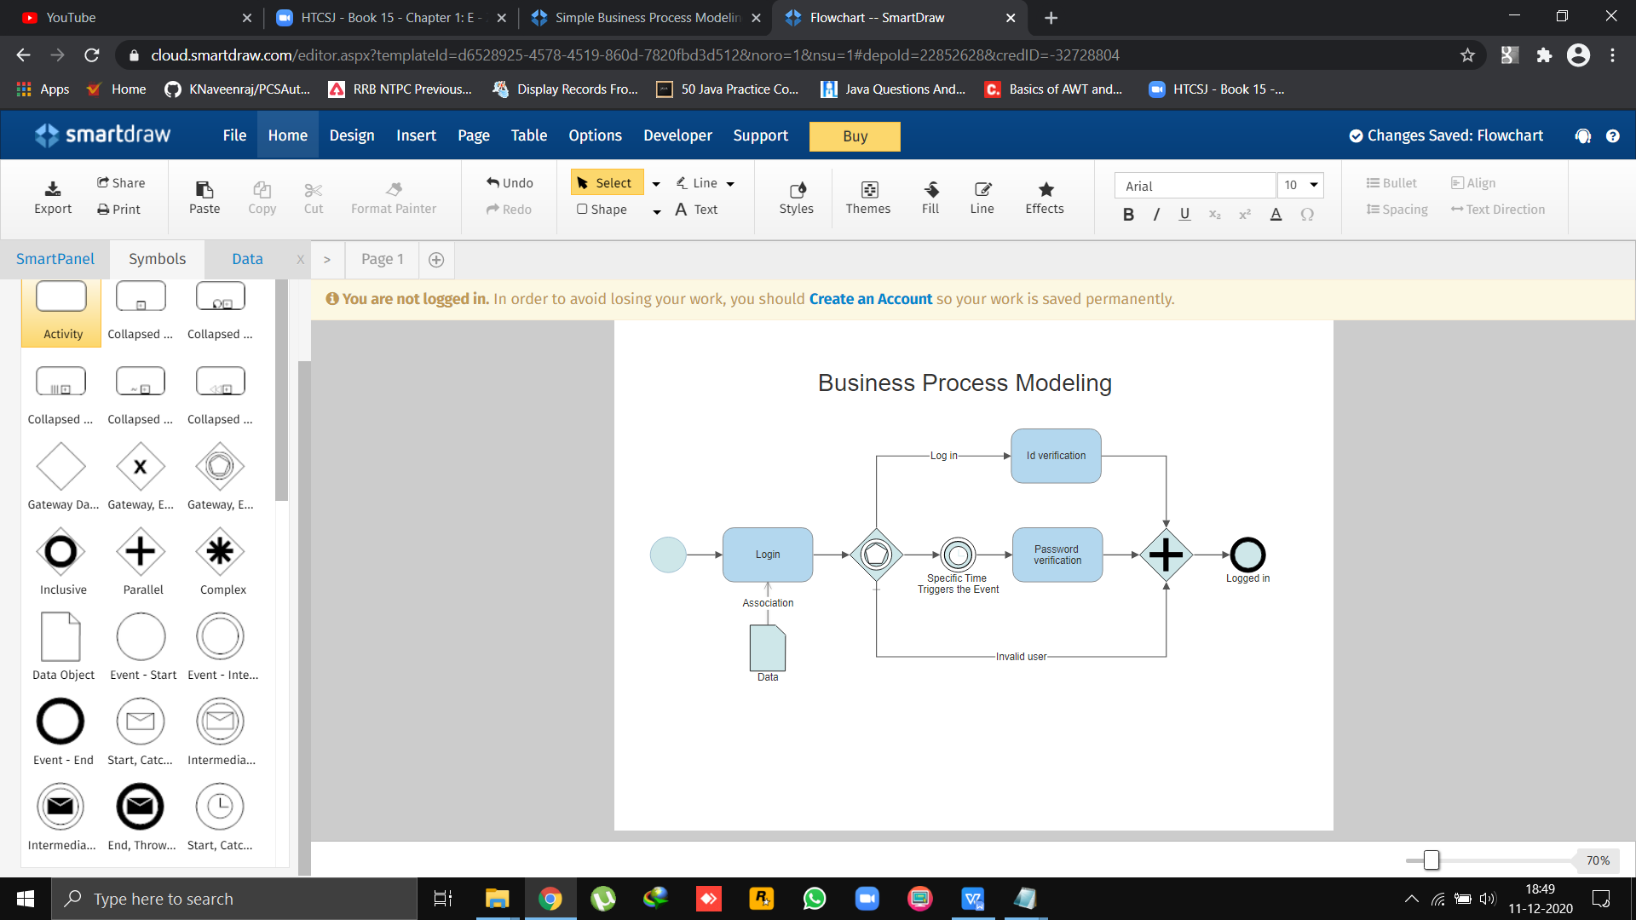

Business process modeling (or) process modeling, is the analytical representation or put simply an illustration of an organization’s business processes. Modeling processes is a critical component for effective [business process management](https://kissflow.com/bpm/business-process-management-overview/" \t "https://kissflow.com/bpm/business-process-modeling/_blank).

Benefits of business process modeling:

* Gives everyone a clear understanding of how the process works
* Provides consistency and controls the process
* Identifies and eliminates redundancies and inefficiencies
* Sets a clear starting and ending to the process

##### SOFTWARE REQUIREMNETS SPECIFICATION

Table of Contents

1. Introduction
   1. Purpose
   2. Scope
   3. Definitions,acronyms and abbreviations
   4. References
   5. Overview
2. General Description

2.1 Product perspective

2.2 Product functions

2.3 User characteristics

2.4 Constraints

2.5 Assumption and dependencies

1. Specific Requirements

3.1 Functional requirements

3.2 Non-functional requirements

3.3 External interface requirements

3.4 Performance requirements

3.5 Design constraints

3.6 Attributes

3.7 Other requirements

1. Appendices
2. Index

#### HIGH LEVEL USER CASE DIAGRAMS

Validation

Home

NAV

Admin

User

Sign Up

Sign In

**Registration Form**



User

Admin

### 





Blogging

Viewing





Activation

Approving

DATABASE

Hibernate config

CRUD/BackEnd

FrontEnd

#### LOW LEVEL USER CASE DIAGRAMS

Database

Layer

Application

Layer

User Interface Layer

User-list

Activation

Approving

**ADMIN**

Update / Delete

Login/Logout

Profile

Job

Recuriment

Post-job

Update-Profile

User-Profile

View-Blog

**USER**

Post-Blog

Login/Logout

Job

Apply-job

### DATABASE STRUCTURE

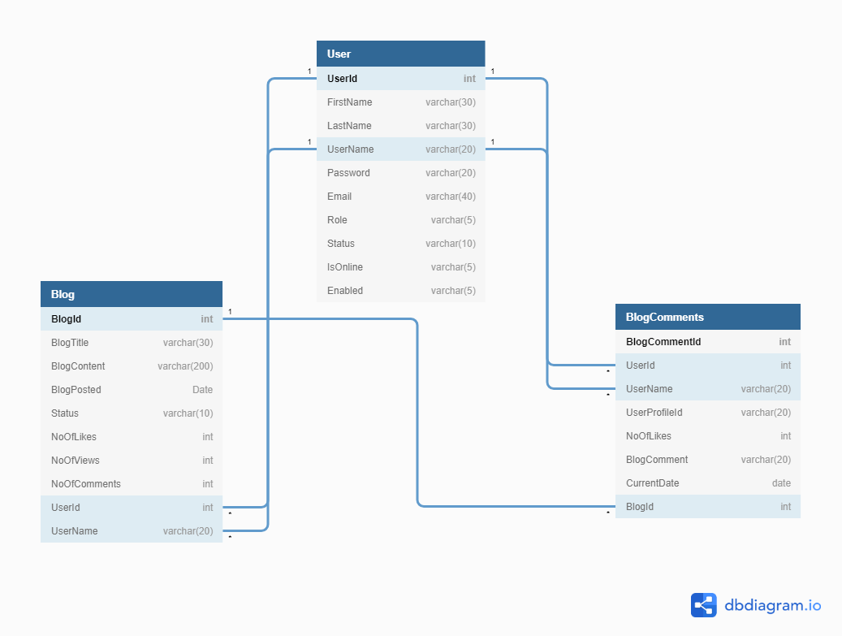

MySQL download-install-setup:

<https://dev.mysql.com/downloads/file/?id=497106>

[https://www.mysqltutorial.org/install-mysql/#:~:text=Install%20MySQL%20via%20MySQL%20Installer&text=Install%20MySQL%20Step%203%20%E2%80%93%20Download,server%2C%20MySQL%20Workbench%2C%20etc.&text=Install%20MySQL%20Step%205%20%E2%80%93%20Choosing,are%20several%20setup%20types%20available.](https://www.mysqltutorial.org/install-mysql/" \l ":~:text=Install%20MySQL%20via%20MySQL%20Installer&text=Install%20MySQL%20Step%203%20%E2%80%93%20Download,server%2C%20MySQL%20Workbench%2C%20etc.&text=Install%20MySQL%20Step%205%20%E2%80%93%20Choosing,are%20several%20setup%20types%20available.)

<https://www.youtube.com/watch?v=X_umYKqKaF0>

create database collaboration;

use collaboration;

create Table User(

UserId int not null auto_increment,

FirstName varchar(30),

LastName varchar(30),

UserName varchar(20),

Password varchar(20),

Email varchar(40),

Role varchar(5),

Status varchar(10),

IsOnline varchar(5),

Enabled varchar(5),

primary key(UserId));

create table Blog(

BlogId int not null auto_increment,

BlogTitle varchar(30),

BlogContent varchar(200),

BlogPosted Date,

Status varchar(10),

NoOfLikes int,

NoOfViews int,

NoOfComments int,

UserId int,

UserName varchar(20),

primary key(BlogId),

);

create table BlogComments(

BlogCommentId int not null auto_increment,

UserId int,

UserName varchar(20),

UserProfileId varchar(20),

NoOfLikes int,

BlogComment varchar(20),

CurrentDate date,

BlogId int,

primary key(BlogCommentId),

);

**Project:**

1. Create a SpringBoot project named OnlineCollaboration with web,

Spring Data JPA, SpringBoot Dev Tools and MySQL Server Driver packages. Extract that project.

1. Import the project in Eclipse.
2. Create the configuration class  
    Instead of XML, we perform annotation-based configuration. So, we create a class HibernateConfig.java and specify the required configuration in it. However, there is one more configuration class OnlineCollaborateApplication.java. This class is provided by Spring Boot automatically.

### pom.xml

<?xml version=*"1.0"* encoding=*"UTF-8"*?>

<project xmlns=*"http://maven.apache.org/POM/4.0.0"* xmlns:xsi=*"http://www.w3.org/2001/XMLSchema-instance"*

xsi:schemaLocation=*"http://maven.apache.org/POM/4.0.0 https://maven.apache.org/xsd/maven-4.0.0.xsd"*>

<modelVersion>4.0.0</modelVersion>

<parent>

<groupId>org.springframework.boot</groupId>

<artifactId>spring-boot-starter-parent</artifactId>

<version>2.4.2</version>

<relativePath/> <!-- lookup parent from repository -->

</parent>

<groupId>com.coll</groupId>

<artifactId>OnlineCollaborate</artifactId>

<version>0.0.1-SNAPSHOT</version>

<name>OnlineCollaborate</name>

<description>Demo project for Spring Boot</description>

<properties>

<java.version>1.8</java.version>

</properties>

<dependencies>

<dependency>

<groupId>org.springframework.boot</groupId>

<artifactId>spring-boot-starter-data-jpa</artifactId>

</dependency>

<dependency>

<groupId>org.springframework.boot</groupId>

<artifactId>spring-boot-starter-mail</artifactId>

</dependency>

<dependency>

<groupId>org.springframework.boot</groupId>

<artifactId>spring-boot-starter-validation</artifactId>

</dependency>

<dependency>

<groupId>org.springframework.boot</groupId>

<artifactId>spring-boot-starter-web</artifactId>

</dependency>

<dependency>

<groupId>mysql</groupId>

<artifactId>mysql-connector-java</artifactId>

<scope>runtime</scope>

</dependency>

<dependency>

<groupId>org.springframework.boot</groupId>

<artifactId>spring-boot-starter-test</artifactId>

<scope>test</scope>

</dependency>

</dependencies>

<build>

<plugins>

<plugin>

<groupId>org.springframework.boot</groupId>

<artifactId>spring-boot-maven-plugin</artifactId>

</plugin>

</plugins>

</build>

</project>

### HibernateConfig

package com.coll.OnlineCollaborate.config;

import java.util.Properties;

import javax.sql.DataSource;

import org.hibernate.SessionFactory;

import org.springframework.boot.autoconfigure.EnableAutoConfiguration;

import org.springframework.boot.autoconfigure.orm.jpa.HibernateJpaAutoConfiguration;

import org.springframework.context.annotation.Bean;

import org.springframework.context.annotation.ComponentScan;

import org.springframework.context.annotation.ComponentScans;

import org.springframework.context.annotation.Configuration;

import org.springframework.http.converter.json.MappingJackson2HttpMessageConverter;

import org.springframework.jdbc.datasource.DriverManagerDataSource;

import org.springframework.orm.hibernate5.HibernateTransactionManager;

import org.springframework.orm.hibernate5.LocalSessionFactoryBean;

import org.springframework.orm.hibernate5.LocalSessionFactoryBuilder;

import org.springframework.transaction.annotation.EnableTransactionManagement;

import org.springframework.web.servlet.ViewResolver;

import org.springframework.web.servlet.view.InternalResourceViewResolver;

import com.fasterxml.jackson.databind.DeserializationFeature;

import com.fasterxml.jackson.databind.ObjectMapper;

@Configuration

@ComponentScans(value= {@ComponentScan("com.coll.OnlineCollaborate"),

@ComponentScan("model"),

@ComponentScan("controller"),

@ComponentScan("dao"),

@ComponentScan("daoImpl"),

@ComponentScan("config"),

@ComponentScan("serviceImpl"),

@ComponentScan("service"),

})

@EnableAutoConfiguration(exclude = {HibernateJpaAutoConfiguration.class})

@EnableTransactionManagement

public class HibernateConfig {

public static final String DATABASE_URL="jdbc:mysql://localhost:3306/collaboration";

public static final String DATABASE_DRIVER="com.mysql.cj.jdbc.Driver";

public static final String DATABASE_DIALECT="org.hibernate.dialect.MySQLDialect";

public static final String DATABASE_USERNAME="root";

public static final String DATABASE_PASSWORD="krishnanCse@76";

@Bean(name="dataSource")

public DataSource getDataSource() {

DriverManagerDataSource dataSource=new DriverManagerDataSource();

dataSource.setDriverClassName(DATABASE_DRIVER);

dataSource.setUrl(DATABASE_URL);

dataSource.setUsername(DATABASE_USERNAME);

dataSource.setPassword(DATABASE_PASSWORD);

return dataSource;

}

@Bean

public LocalSessionFactoryBean getSessionFactory() {

LocalSessionFactoryBean sessionFactory = new LocalSessionFactoryBean();

sessionFactory.setDataSource(getDataSource());

sessionFactory.setPackagesToScan("com.coll.OnlineCollaborate");

Properties hibernateProperties =new Properties();

hibernateProperties.put("hibernate.dialect",DATABASE_DIALECT);

hibernateProperties.put("hibernate.show_sql","true");

hibernateProperties.put("hibernate.hbm2ddl.auto","update");

sessionFactory.setHibernateProperties(hibernateProperties);

return sessionFactory;

}

@Bean

public HibernateTransactionManager getTransactionManger() {

HibernateTransactionManager txm=new HibernateTransactionManager();

txm.setSessionFactory(getSessionFactory().getObject());

return txm;

}

@Bean

public ViewResolver jspViewResolver() {

InternalResourceViewResolver viewResolver= new InternalResourceViewResolver();

viewResolver.setPrefix("/views/");

viewResolver.setSuffix(".jsp");

return viewResolver;

}

@Bean

public MappingJackson2HttpMessageConverter mappingJackson2HttpMessageConverter() {

MappingJackson2HttpMessageConverter jsonConverter = new MappingJackson2HttpMessageConverter();

ObjectMapper objectMapper = new ObjectMapper();

objectMapper.configure(DeserializationFeature.FAIL_ON_UNKNOWN_PROPERTIES, false);

jsonConverter.setObjectMapper(objectMapper);

return jsonConverter;

}

}

### OnlineCollaborateApplication

package com.coll.OnlineCollaborate;

import org.springframework.boot.SpringApplication;

import org.springframework.boot.autoconfigure.SpringBootApplication;

@SpringBootApplication

public class OnlineCollaborateApplication {

public static void main(String[] args) {

SpringApplication.run(OnlineCollaborateApplication.class, args);

}

}

1. Create the entity class  
   Here, we are creating an Entity/POJO (Plain Old Java Object) class.

### 4(a) User.model

package com.coll.OnlineCollaborate.model;

import java.io.Serializable;

import javax.persistence.Entity;

import javax.persistence.GeneratedValue;

import javax.persistence.GenerationType;

import javax.persistence.Id;

import javax.persistence.Transient;

import org.springframework.stereotype.Component;

@Component

@Entity

public class User extends DomainResponse implements Serializable {

private static final long serialVersionUID=1L;

@Id

@GeneratedValue(strategy=GenerationType.IDENTITY)

private int userId;

private String firstName;

private String lastName;

private String username;

private String password;

private String email;

private String role;

private String status;

private String isOnline;

private String enabled;

public int getUserId() {

return userId;

}

public void setUserId(int userId) {

this.userId = userId;

}

public String getFirstName() {

return firstName;

}

public void setFirstName(String firstName) {

this.firstName = firstName;

}

public String getLastName() {

return lastName;

}

public void setLastName(String lastName) {

this.lastName = lastName;

}

public String getUsername() {

return username;

}

public void setUsername(String username) {

this.username = username;

}

public String getPassword() {

return password;

}

public void setPassword(String password) {

this.password = password;

}

public String getEmail() {

return email;

}

public void setEmail(String email) {

this.email = email;

}

public String getRole() {

return role;

}

public void setRole(String role) {

this.role = role;

}

public String getStatus() {

return status;

}

public void setStatus(String status) {

this.status = status;

}

public String getIsOnline() {

return isOnline;

}

public void setIsOnline(String isOnline) {

this.isOnline = isOnline;

}

public String getEnabled() {

return enabled;

}

public void setEnabled(String enabled) {

this.enabled = enabled;

}

}

5.Create the DAO interface implementation class

### 5(a) User.dao

package com.coll.OnlineCollaborate.dao;

import java.util.List;

import com.coll.OnlineCollaborate.model.User;

public interface IUserDao {

List<User> userListbyStatus(String status);

List<User> getAllusers();

User getUserById(int userId);

User getUserByName(String username);

User validateUser(User user);

boolean addUser(User user);

boolean updateUser(User user);

boolean deleteUser(int userId);

boolean deactiveUser(int userId);

boolean activeUser(int userId);

boolean logoutUser(int userId);

List<User> getAllDeactiveUser();

List<User> getAllActiveUser();

boolean updateUserProfile(String file, Integer userId);

}

6.Create the DAO interface implementation class

### 6(a) User.daoImpl

package com.coll.OnlineCollaborate.daoImpl;

import java.util.List;

import org.hibernate.SessionFactory;

import org.hibernate.query.Query;

import org.springframework.beans.factory.annotation.Autowired;

import org.springframework.stereotype.Repository;

import org.springframework.transaction.annotation.Transactional;

import com.coll.OnlineCollaborate.dao.IUserDao;

import com.coll.OnlineCollaborate.model.User;

@Repository("userDao")

@Transactional

public class UserDaoImpl implements IUserDao {

@Autowired

SessionFactory sessionFactory;

@Override

public List<User> userListbyStatus(String status) {

String q="from User wheere status="+status+"'";

Query query=sessionFactory.getCurrentSession().createQuery(q);

return query.getResultList();

}

@Override

public List<User> getAllusers() {

return sessionFactory.getCurrentSession().createQuery("from User",User.class).getResultList();

}

@Override

public User getUserById(int userId) {

return sessionFactory.getCurrentSession().get(User.class, Integer.valueOf(userId));

}

@Override

public User getUserByName(String username) {

String query="from User where username=:username";

return sessionFactory.getCurrentSession().createQuery(query,User.class).setParameter("username", username).getSingleResult();

}

@Override

public User validateUser(User user) {

String username=user.getUsername();

String password=user.getPassword();

String q="from User where username='"+username+"' and password='"+password+"'and enabled='true'";

Query query=sessionFactory.getCurrentSession().createQuery(q);

try {

user=(User)query.getSingleResult();

user.setIsOnline("true");

return user;

}

catch(Exception e) {

e.printStackTrace();

return null;

}

}

@Override

public boolean addUser(User user) {

try {

sessionFactory.getCurrentSession().save(user);

return true;

}

catch(Exception ex) {

ex.printStackTrace();

return false;

}

}

@Override

public boolean updateUser(User user) {

try {

sessionFactory.getCurrentSession().update(user);

return true;

}

catch(Exception ex) {

ex.printStackTrace();

return false;

}

}

@Override

public boolean deleteUser(int userId) {

try {

sessionFactory.getCurrentSession().delete(getUserById(userId));

return true;

}

catch(Exception ex) {

ex.printStackTrace();

return false;

}

}

@Override

public boolean deactiveUser(int userId) {

try {

User user=getUserById(userId);

user.setEnabled("false");

user.setStatus("Inactive");

sessionFactory.getCurrentSession().update(user);

return true;

}

catch(Exception ex) {

ex.printStackTrace();

return false;

}

}

@Override

public boolean updateUserProfile(String file, Integer userId) {

String q="update User set profile=:filename where userId=:id";

Query query=sessionFactory.getCurrentSession().createQuery(q);

query.setParameter("id",(Integer)userId);

query.setParameter("filename", file);

try {

query.executeUpdate();

return true;

}

catch(Exception e) {

e.printStackTrace();

return false;

}

}

@Override

public boolean activeUser(int userId) {

try {

User user=getUserById(userId);

user.setEnabled("true");

user.setStatus("Active");

sessionFactory.getCurrentSession().update(user);

return true;

}

catch(Exception ex) {

ex.printStackTrace();

return false;

}

}

@Override

public List<User> getAllDeactiveUser() {

return sessionFactory.getCurrentSession().createQuery("from User where enabled='false'",User.class).getResultList();

}

@Override

public boolean logoutUser(int userId) {

try {

User user=getUserById(userId);

user.setIsOnline("false");

sessionFactory.getCurrentSession().update(user);

return true;

}

catch(Exception ex) {

ex.printStackTrace();

return false;

}

}

@Override

public List<User> getAllActiveUser() {

return sessionFactory.getCurrentSession().createQuery("from User where enabled='true'",User.class).getResultList();

}

}

7.Create the service layer interface

Here, we are creating a service layer interface that acts as a bridge between DAO and Entity classes.

### 7(a) User.service

package com.coll.OnlineCollaborate.service;

import java.util.List;

import com.coll.OnlineCollaborate.model.User;

public interface IUserService {

List<User> userListbyStatus(String status);

List<User> getAllusers();

User getUserById(int userId);

User getUserByName(String username);

User validateUser(User user);

boolean addUser(User user);

boolean updateUser(User user);

boolean deleteUser(int userId);

boolean deactiveUser(int userId);

boolean activeUser(int userId);

boolean logoutUser(int userId);

List<User> getAllDeactiveUser();

List<User> getAllActiveUser();

boolean updateUserProfile(String file, Integer userId);

}

8.Create the service layer implementation class

### 8(a) User.serviceImpl

package com.coll.OnlineCollaborate.serviceImpl;

import java.util.List;

import org.springframework.beans.factory.annotation.Autowired;

import org.springframework.stereotype.Service;

import org.springframework.transaction.annotation.Transactional;

import com.coll.OnlineCollaborate.dao.IUserDao;

import com.coll.OnlineCollaborate.model.User;

import com.coll.OnlineCollaborate.service.IUserService;

@Service

@Transactional

public class UserServiceImpl implements IUserService {

@Autowired

IUserDao userDao;

@Override

public List<User> userListbyStatus(String status) {

// TODO Auto-generated method stub

return userDao.userListbyStatus(status);

}

@Override

public List<User> getAllusers() {

// TODO Auto-generated method stub

return userDao.getAllusers();

}

@Override

public User getUserById(int userId) {

// TODO Auto-generated method stub

return userDao.getUserById(userId);

}

@Override

public User getUserByName(String username) {

// TODO Auto-generated method stub

return userDao.getUserByName(username);

}

@Override

public User validateUser(User user) {

// TODO Auto-generated method stub

return userDao.validateUser(user);

}

@Override

public boolean addUser(User user) {

// TODO Auto-generated method stub

return userDao.addUser(user);

}

@Override

public boolean updateUser(User user) {

// TODO Auto-generated method stub

return userDao.updateUser(user);

}

@Override

public boolean deleteUser(int userId) {

// TODO Auto-generated method stub

return userDao.deleteUser(userId);

}

@Override

public boolean deactiveUser(int userId) {

// TODO Auto-generated method stub

return userDao.deactiveUser(userId);

}

@Override

public boolean updateUserProfile(String file, Integer userId) {

// TODO Auto-generated method stub

return userDao.updateUserProfile(file, userId);

}

@Override

public boolean activeUser(int userId) {

// TODO Auto-generated method stub

return userDao.activeUser(userId);

}

@Override

public List<User> getAllDeactiveUser() {

// TODO Auto-generated method stub

return userDao.getAllDeactiveUser();

}

@Override

public boolean logoutUser(int userId) {

// TODO Auto-generated method stub

return userDao.logoutUser(userId);

}

@Override

public List<User> getAllActiveUser() {

// TODO Auto-generated method stub

return userDao.getAllActiveUser();

}

}

9.Create the controller class

### 9(a) User.controller

package com.coll.OnlineCollaborate.controller;

import java.util.List;

import org.springframework.beans.factory.annotation.Autowired;

import org.springframework.web.bind.annotation.CrossOrigin;

import org.springframework.web.bind.annotation.DeleteMapping;

import org.springframework.web.bind.annotation.GetMapping;

import org.springframework.web.bind.annotation.PathVariable;

import org.springframework.web.bind.annotation.PostMapping;

import org.springframework.web.bind.annotation.RequestBody;

import org.springframework.web.bind.annotation.RequestMapping;

import org.springframework.web.bind.annotation.RestController;

import com.coll.OnlineCollaborate.model.User;

import com.coll.OnlineCollaborate.service.IUserService;

@RestController

@CrossOrigin(origins="http://localhost:4200")

@RequestMapping(value="/api")

public class UserController {

@Autowired

IUserService userService;

@PostMapping("save-user")

public boolean saveUser(@RequestBody User user) {

return userService.addUser(user);

}

@GetMapping("user-list")

public List<User> allUsers(){

return userService.getAllusers();

}

@DeleteMapping("delete-user/{userId}")

public boolean deleteUser(@PathVariable("userId") int userId) {

return userService.deleteUser(userId);

}

@GetMapping("user/{userId}")

public User userById(@PathVariable("userId") int userId) {

return userService.getUserById(userId);

}

@PostMapping("update-user/{userId}")

public boolean updateUser(@RequestBody User user, @PathVariable("userId") int userId) {

user.setUserId(userId);

return userService.updateUser(user);

}

@GetMapping("deactive-list")

public List<User> AllDeactiveUser(){

return userService.getAllDeactiveUser();

}

@PostMapping("active-user/{userId}")

public boolean activeUser(@RequestBody User user, @PathVariable("userId") int userId) {

return userService.activeUser(userId);

}

@GetMapping("active-list")

public List<User> AllActiveUser(){

return userService.getAllActiveUser();

}

@PostMapping("deactive-user/{userId}")

public boolean deactiveUser(@RequestBody User user, @PathVariable("userId") int userId) {

return userService.deactiveUser(userId);

}

@PostMapping("validate-user")

public User validateUser(@RequestBody User user) {

return userService.validateUser(user);

}

@PostMapping("logout-user/{userId}")

public boolean logoutUser(@RequestBody User user, @PathVariable("userId") int userId) {

return userService.logoutUser(userId);

}

}

**4(b)Blog.model**

package com.coll.OnlineCollaborate.model;

import java.io.Serializable;

import java.time.LocalDate;

import java.util.List;

import javax.persistence.CascadeType;

import javax.persistence.Entity;

import javax.persistence.FetchType;

import javax.persistence.GeneratedValue;

import javax.persistence.GenerationType;

import javax.persistence.Id;

import javax.persistence.OneToMany;

import org.springframework.stereotype.Component;

import com.fasterxml.jackson.annotation.JsonIgnore;

import com.fasterxml.jackson.annotation.JsonManagedReference;

@Component

@Entity

public class Blog extends DomainResponse implements Serializable{

private static final long serialVersionUID=1L;

@Id

@GeneratedValue(strategy=GenerationType.IDENTITY)

int blogId;

String blogTitle, blogContent;

LocalDate blogPosted;

String status;

int noOfLikes,noOfComments, noOfViews;

int userId;

String username;

@OneToMany(mappedBy="blog", fetch=FetchType.EAGER,cascade=CascadeType.ALL)

@JsonManagedReference

List<BlogComments> blogComments;

public int getBlogId() {

return blogId;

}

public void setBlogId(int blogId) {

this.blogId = blogId;

}

public String getBlogTitle() {

return blogTitle;

}

public void setBlogTitle(String blogTitle) {

this.blogTitle = blogTitle;

}

public String getBlogContent() {

return blogContent;

}

public void setBlogContent(String blogContent) {

this.blogContent = blogContent;

}

public LocalDate getBlogPosted() {

return blogPosted;

}

public void setBlogPosted(LocalDate blogPosted) {

this.blogPosted = blogPosted;

}

public String getStatus() {

return status;

}

public void setStatus(String status) {

this.status = status;

}

public int getNoOfLikes() {

return noOfLikes;

}

public void setNoOfLikes(int noOfLikes) {

this.noOfLikes = noOfLikes;

}

public int getNoOfComments() {

return noOfComments;

}

public void setNoOfComments(int noOfComments) {

this.noOfComments = noOfComments;

}

public int getNoOfViews() {

return noOfViews;

}

public void setNoOfViews(int noOfViews) {

this.noOfViews = noOfViews;

}

public int getUserId() {

return userId;

}

public void setUserId(int userId) {

this.userId = userId;

}

public String getUsername() {

return username;

}

public void setUsername(String username) {

this.username = username;

}

public List<BlogComments> getBlogComments() {

return blogComments;

}

public void setBlogComments(List<BlogComments> blogComments) {

this.blogComments = blogComments;

}

}

### 5(b) Blog.dao

package com.coll.OnlineCollaborate.dao;

import java.util.List;

import com.coll.OnlineCollaborate.model.Blog;

public interface IBlogDao {

List<Blog> getAllBlogs();

List<Blog> getBlogsByStatus(String status);

List<Blog> getUsersBlogs(int id);

Blog getBlogById(int blogId);

boolean addBlog(Blog blog);

boolean updateBlog(Blog blog);

boolean deleteBlog(int blogId);

}

### 6(b) Blog.daoImpl

package com.coll.OnlineCollaborate.daoImpl;

import java.util.List;

import org.hibernate.SessionFactory;

import org.hibernate.query.Query;

import org.springframework.beans.factory.annotation.Autowired;

import org.springframework.stereotype.Repository;

import org.springframework.transaction.annotation.Transactional;

import com.coll.OnlineCollaborate.dao.IBlogDao;

import com.coll.OnlineCollaborate.model.Blog;

@Repository("blogDao")

@Transactional

public class BlogDaoImpl implements IBlogDao {

@Autowired

SessionFactory sessionFactory;

@Override

public List<Blog> getAllBlogs() {

return sessionFactory.getCurrentSession().createQuery("from Blog",Blog.class).getResultList();

}

@Override

public List<Blog> getBlogsByStatus(String status) {

String q="from Blog where status='"+status+"'";

Query query=sessionFactory.getCurrentSession().createQuery(q);

return query.getResultList();

}

@Override

public List<Blog> getUsersBlogs(int blogId) {

// TODO Auto-generated method stub

return null;

}

@Override

public Blog getBlogById(int blogId) {

return sessionFactory.getCurrentSession().get(Blog.class,Integer.valueOf(blogId));

}

@Override

public boolean addBlog(Blog blog) {

try

{

sessionFactory.getCurrentSession().save(blog);

return true;

}

catch(Exception ex)

{

ex.printStackTrace();

return false;

}

}

@Override

public boolean updateBlog(Blog blog) {

try

{

sessionFactory.getCurrentSession().update(blog);

return true;

}

catch(Exception ex)

{

ex.printStackTrace();

return false;

}

}

@Override

public boolean deleteBlog(Blog blogId) {

try

{

sessionFactory.getCurrentSession().delete(blogId);

return true;

}

catch(Exception ex)

{

ex.printStackTrace();

return false;

}

}

@Override

public List<Blog> mainList() {

// TODO Auto-generated method stub

return null;

}}

### 7(b) Blog.service

package com.coll.OnlineCollaborate.service;

import java.util.List;

import com.coll.OnlineCollaborate.model.Blog;

public interface IBlogService {

List<Blog> getAllBlogs();

List<Blog> getBlogsByStatus(String status);

List<Blog> getUsersBlogs(int blogId);

List<Blog> mainList();

Blog getBlogById(int blogId);

boolean addBlog(Blog blog);

boolean updateBlog(Blog blog);

boolean deleteBlog(Blog blogId);

}

### 8(b) Blog.serviceImpl

package com.coll.OnlineCollaborate.serviceImpl;

import java.util.List;

import org.springframework.beans.factory.annotation.Autowired;

import org.springframework.stereotype.Service;

import org.springframework.transaction.annotation.Transactional;

import com.coll.OnlineCollaborate.dao.IBlogDao;

import com.coll.OnlineCollaborate.model.Blog;

import com.coll.OnlineCollaborate.service.IBlogService;

@Service

@Transactional

public class BlogServiceImpl implements IBlogService {

@Autowired

IBlogDao blogDao;

@Override

public List<Blog> getAllBlogs() {

return blogDao.getAllBlogs();

}

@Override

public List<Blog> getBlogsByStatus(String status) {

return blogDao.getBlogsByStatus(status);

}

@Override

public List<Blog> getUsersBlogs(int blogId) {

return blogDao.getUsersBlogs(blogId);

}

@Override

public List<Blog> mainList() {

return blogDao.mainList();

}

@Override

public Blog getBlogById(int blogId) {

return blogDao.getBlogById(blogId);

}

@Override

public boolean addBlog(Blog blog) {

return blogDao.addBlog(blog);

}

@Override

public boolean updateBlog(Blog blog) {

return blogDao.updateBlog(blog);

}

@Override

public boolean deleteBlog(Blog blogId) {

return blogDao.deleteBlog(blogId);

}

}

### 9(b) Blog.controller

package com.coll.OnlineCollaborate.controller;

import java.util.List;

import org.springframework.beans.factory.annotation.Autowired;

import org.springframework.web.bind.annotation.CrossOrigin;

import org.springframework.web.bind.annotation.DeleteMapping;

import org.springframework.web.bind.annotation.GetMapping;

import org.springframework.web.bind.annotation.PathVariable;

import org.springframework.web.bind.annotation.PostMapping;

import org.springframework.web.bind.annotation.RequestBody;

import org.springframework.web.bind.annotation.RequestMapping;

import org.springframework.web.bind.annotation.RestController;

import com.coll.OnlineCollaborate.model.Blog;

import com.coll.OnlineCollaborate.service.IBlogService;

@RestController

@CrossOrigin(origins="http://localhost:4200")

@RequestMapping(value="/api")

public class BlogController {

@Autowired

IBlogService blogService;

@PostMapping("save-blog")

public boolean saveBlog(@RequestBody Blog blog)

{

return blogService.addBlog(blog);

}

@GetMapping("blog-list")

public List<Blog> allBlog()

{

return blogService.getAllBlogs();

}

@DeleteMapping("delete-blog/{blog_id}")

public boolean deleteBlog(@PathVariable("blog_id") Blog blog_id)

{

return blogService.deleteBlog(blog_id);

}

@GetMapping("blog/{blog_id}")

public Blog blogById(@PathVariable("blog_id") int blog_id)

{

return blogService.getBlogById(blog_id);

}

@PostMapping("update-blog/{blog}")

public boolean updateBlog(@PathVariable("blog") Blog blog)

{

return blogService.updateBlog(blog);

}

}

### 4(c) Blogcomments.model

package com.coll.OnlineCollaborate.model;

import java.io.Serializable;

import java.time.LocalDate;

import javax.persistence.Entity;

import javax.persistence.GeneratedValue;

import javax.persistence.GenerationType;

import javax.persistence.Id;

import javax.persistence.JoinColumn;

import javax.persistence.ManyToOne;

import org.springframework.stereotype.Component;

import com.fasterxml.jackson.annotation.JsonBackReference;

@Component

@Entity

public class BlogComments implements Serializable {

private static final long serialVersionUID = 1L;

@Id

@GeneratedValue(strategy=GenerationType.IDENTITY)

int blogCommentId;

int userId;

String username;

String userProfileId;

String title;

int noOfLikes;

String blogComment;

LocalDate currentDate;

@ManyToOne

@JoinColumn(name="BlogId")

@JsonBackReference

Blog blog;

public int getBlogCommentId() {

return blogCommentId;

}

public void setBlogCommentId(int blogCommentId) {

this.blogCommentId = blogCommentId;

}

public int getUserId() {

return userId;

}

public void setUserId(int userId) {

this.userId = userId;

}

public String getUsername() {

return username;

}

public void setUsername(String username) {

this.username = username;

}

public String getUserProfileId() {

return userProfileId;

}

public void setUserProfileId(String userProfileId) {

this.userProfileId = userProfileId;

}

public String getTitle() {

return title;

}

public void setTitle(String title) {

this.title = title;

}

public int getNoOfLikes() {

return noOfLikes;

}

public void setNoOfLikes(int noOfLikes) {

this.noOfLikes = noOfLikes;

}

public String getBlogComment() {

return blogComment;

}

public void setBlogComment(String blogComment) {

this.blogComment = blogComment;

}

public LocalDate getCurrentDate() {

return currentDate;

}

public void setCurrentDate(LocalDate currentDate) {

this.currentDate = currentDate;

}

public Blog getBlog() {

return blog;

}

public void setBlog(Blog blog) {

this.blog = blog;

}

public static long getSerialversionuid() {

return serialVersionUID;

}

}

### 5(c) Blogcomments.dao

package com.coll.OnlineCollaborate.dao;

import java.util.List;

import com.coll.OnlineCollaborate.model.BlogComments;

public interface IBlogCommentsDao {

List<BlogComments> getAllBlogComments();

BlogComments getBlogCommentsById(int blogCommentId);

boolean addBlogComments(BlogComments blogComments);

boolean updateBlogComments(BlogComments blogComments);

boolean deleteBlogComments(BlogComments blogCommentId);

}

### 6(c) Blogcomments.daoImpl

package com.coll.OnlineCollaborate.daoImpl;

import java.util.List;

import org.hibernate.SessionFactory;

import org.springframework.beans.factory.annotation.Autowired;

import org.springframework.stereotype.Repository;

import org.springframework.transaction.annotation.Transactional;

import com.coll.OnlineCollaborate.dao.IBlogCommentsDao;

import com.coll.OnlineCollaborate.model.BlogComments;

@Repository("blogCommentsDao")

@Transactional

public class BlogCommentsDaoImpl implements IBlogCommentsDao{

@Autowired

SessionFactory sessionFactory;

@Override

public List<BlogComments> getAllBlogComments() {

return sessionFactory.getCurrentSession().createQuery("from BlogComments",BlogComments.class).getResultList();

}

@Override

public BlogComments getBlogCommentsById(int blogCommentId) {

return sessionFactory.getCurrentSession().get(BlogComments.class,Integer.valueOf(blogCommentId));

}

@Override

public boolean addBlogComments(BlogComments blogComments) {

try

{

sessionFactory.getCurrentSession().save(blogComments);

return true;

}

catch(Exception ex)

{

ex.printStackTrace();

return false;

}

}

@Override

public boolean updateBlogComments(BlogComments blogComments) {

try

{

sessionFactory.getCurrentSession().update(blogComments);

return true;

}

catch(Exception ex)

{

ex.printStackTrace();

return false;

}

}

@Override

public boolean deleteBlogComments(BlogComments blogCommentId) {

try

{

sessionFactory.getCurrentSession().delete(blogCommentId);

return true;

}

catch(Exception ex)

{

ex.printStackTrace();

return false;

}

}

}

### 7(c) Blogcomments.service

package com.coll.OnlineCollaborate.service;

import java.util.List;

import com.coll.OnlineCollaborate.model.BlogComments;

public interface IBlogCommentsService {

List<BlogComments> getAllBlogComments();

BlogComments getBlogCommentsById(int blogCommentId);

boolean addBlogComments(BlogComments blogComments);

boolean updateBlogComments(BlogComments blogComments);

boolean deleteBlogComments(BlogComments blogCommentId);

}

### 8(c) Blogcomments.serviceImpl

package com.coll.OnlineCollaborate.serviceImpl;

import java.util.List;

import org.springframework.beans.factory.annotation.Autowired;

import org.springframework.stereotype.Service;

import org.springframework.transaction.annotation.Transactional;

import com.coll.OnlineCollaborate.dao.IBlogCommentsDao;

import com.coll.OnlineCollaborate.model.BlogComments;

import com.coll.OnlineCollaborate.service.IBlogCommentsService;

@Service

@Transactional

public class BlogCommentsServiceImpl implements IBlogCommentsService {

@Autowired

IBlogCommentsDao blogCommentsDao;

@Override

public List<BlogComments> getAllBlogComments() {

return blogCommentsDao.getAllBlogComments();

}

@Override

public BlogComments getBlogCommentsById(int blogCommentId) {

return blogCommentsDao.getBlogCommentsById(blogCommentId);

}

@Override

public boolean addBlogComments(BlogComments blogComments) {

return blogCommentsDao.addBlogComments(blogComments);

}

@Override

public boolean updateBlogComments(BlogComments blogComments) {

return blogCommentsDao.updateBlogComments(blogComments);

}

@Override

public boolean deleteBlogComments(BlogComments blogCommentId) {

return blogCommentsDao.deleteBlogComments(blogCommentId);

}

}

### 9(c) Blogcomments.controller

package com.coll.OnlineCollaborate.controller;

import java.util.List;

import org.springframework.beans.factory.annotation.Autowired;

import org.springframework.web.bind.annotation.CrossOrigin;

import org.springframework.web.bind.annotation.DeleteMapping;

import org.springframework.web.bind.annotation.GetMapping;

import org.springframework.web.bind.annotation.PathVariable;

import org.springframework.web.bind.annotation.PostMapping;

import org.springframework.web.bind.annotation.RequestBody;

import org.springframework.web.bind.annotation.RequestMapping;

import org.springframework.web.bind.annotation.RestController;

import com.coll.OnlineCollaborate.model.BlogComments;

import com.coll.OnlineCollaborate.service.IBlogCommentsService;

@RestController

@CrossOrigin(origins="http://localhost:4200")

@RequestMapping(value="/api")

public class BlogCommentsController {

@Autowired

IBlogCommentsService blogCommentsService;

@PostMapping("save-blogComments")

public boolean saveBlogComments(@RequestBody BlogComments blogComments)

{

return blogCommentsService.addBlogComments(blogComments);

}

@GetMapping("blogComments-list")

public List<BlogComments> allBlogComments()

{

return blogCommentsService.getAllBlogComments();

}

@DeleteMapping("delete-blogComments/{blogComment_id}")

public boolean deleteBlogComments(@PathVariable("blogComment_id") BlogComments blogComment_id)

{

return blogCommentsService.deleteBlogComments(blogComment_id);

}

@GetMapping("blogComments/{blogComments_id}")

public BlogComments blogCommentsById(@PathVariable("blogComments_id") int blogComments_id)

{

return blogCommentsService.getBlogCommentsById(blogComments_id);

}

@PostMapping("update-blogComments/{blogComments}")

public boolean updateBlog(@PathVariable("blogComments") BlogComments blogComments)

{

return blogCommentsService.updateBlogComments(blogComments);

}

}

10.Edit application.properties file  
Here, we are editing the **application.properties** file present inside the **src/main/resources** folder. The following file contains the configuration properties.

**# Database**

public static final String *DATABASE_URL*="jdbc:mysql://localhost:3306/collaboration";

public static final String *DATABASE_DRIVER*="com.mysql.cj.jdbc.Driver";

public static final String *DATABASE_DIALECT*="org.hibernate.dialect.MySQLDialect";

public static final String *DATABASE_USERNAME*="root";

public static final String *DATABASE_PASSWORD*="krishnanCse@76";

**# Hibernate**

sessionFactory.setPackagesToScan("com.coll.OnlineCollaborate");

Properties hibernateProperties=new Properties();

hibernateProperties.put("hibernate.dialect",*DATABASE_DIALECT*);

hibernateProperties.put("hibernate.show_sql","true");

hibernateProperties.put("hibernate.hbm2dll.auto","update");

sessionFactory.setHibernateProperties(hibernateProperties);

11. Open Visual Studio Code. Create new project inside Angular_Workspace. Set the project name as OnlineCollaborateAngular

ng new OnlineCollaborateAngular

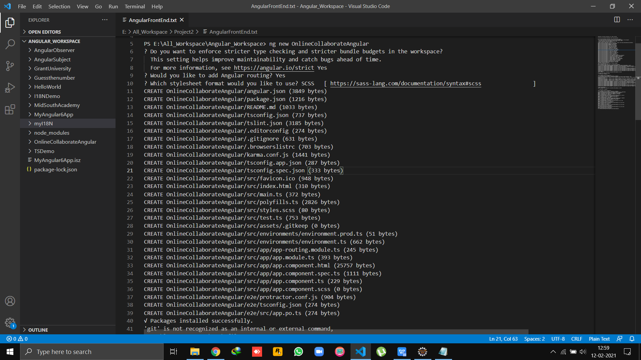

12.Install Bootstrap CSS framework

Use the following command to install bootstrap in the project.

*E:\All_Workspace\Angular_Workspace\OnlineCollaborateAngular>* ***npm install [bootstrap@3.3.7](mailto:bootstrap@3.3.7) --save***

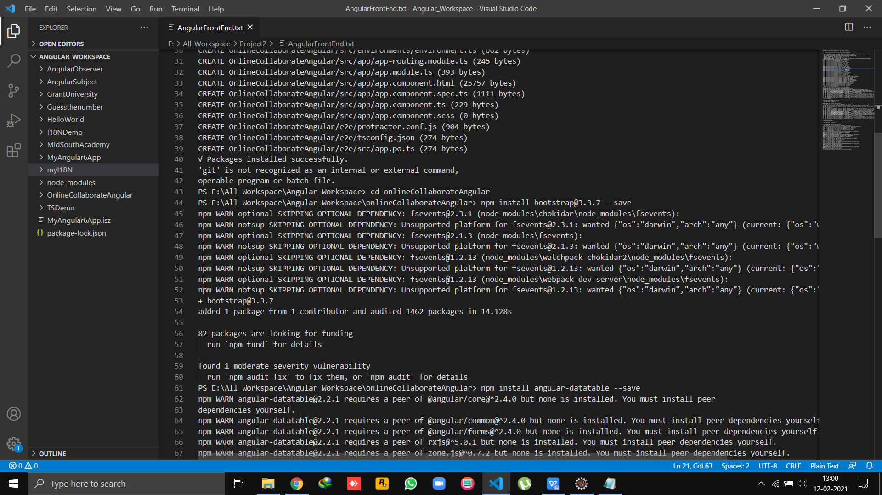

13.Now, include the following code in the style.css file.

@import "~bootstrap/dist/css/bootstrap.css";

14.Install Angular Data Table

Use the following command to install bootstrap in the project.

*E:\All_Workspace\Angular_Workspace\OnlineCollaborateAngular>* ***npm install angular-datatable --save***

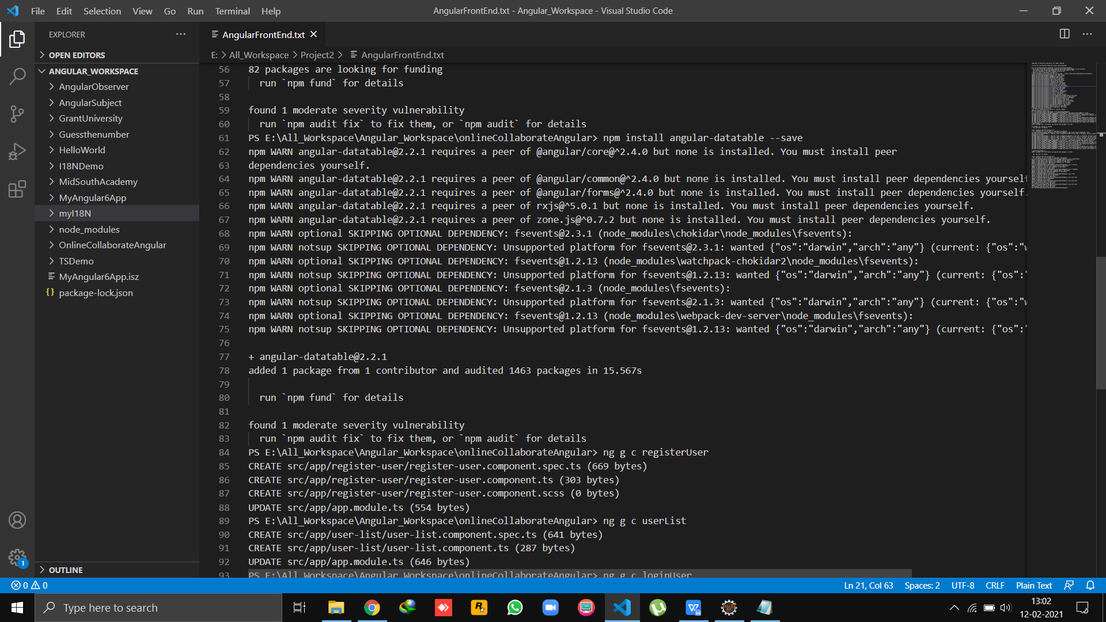

1. It is required to include **DataTablesModule** in imports array of **app.module.ts** file.
2. Generate Components  
   Open the project in visual studio and then use the following command to generate Angular components:

ng g c registerUser

ng g c userList

ng g c loginUser

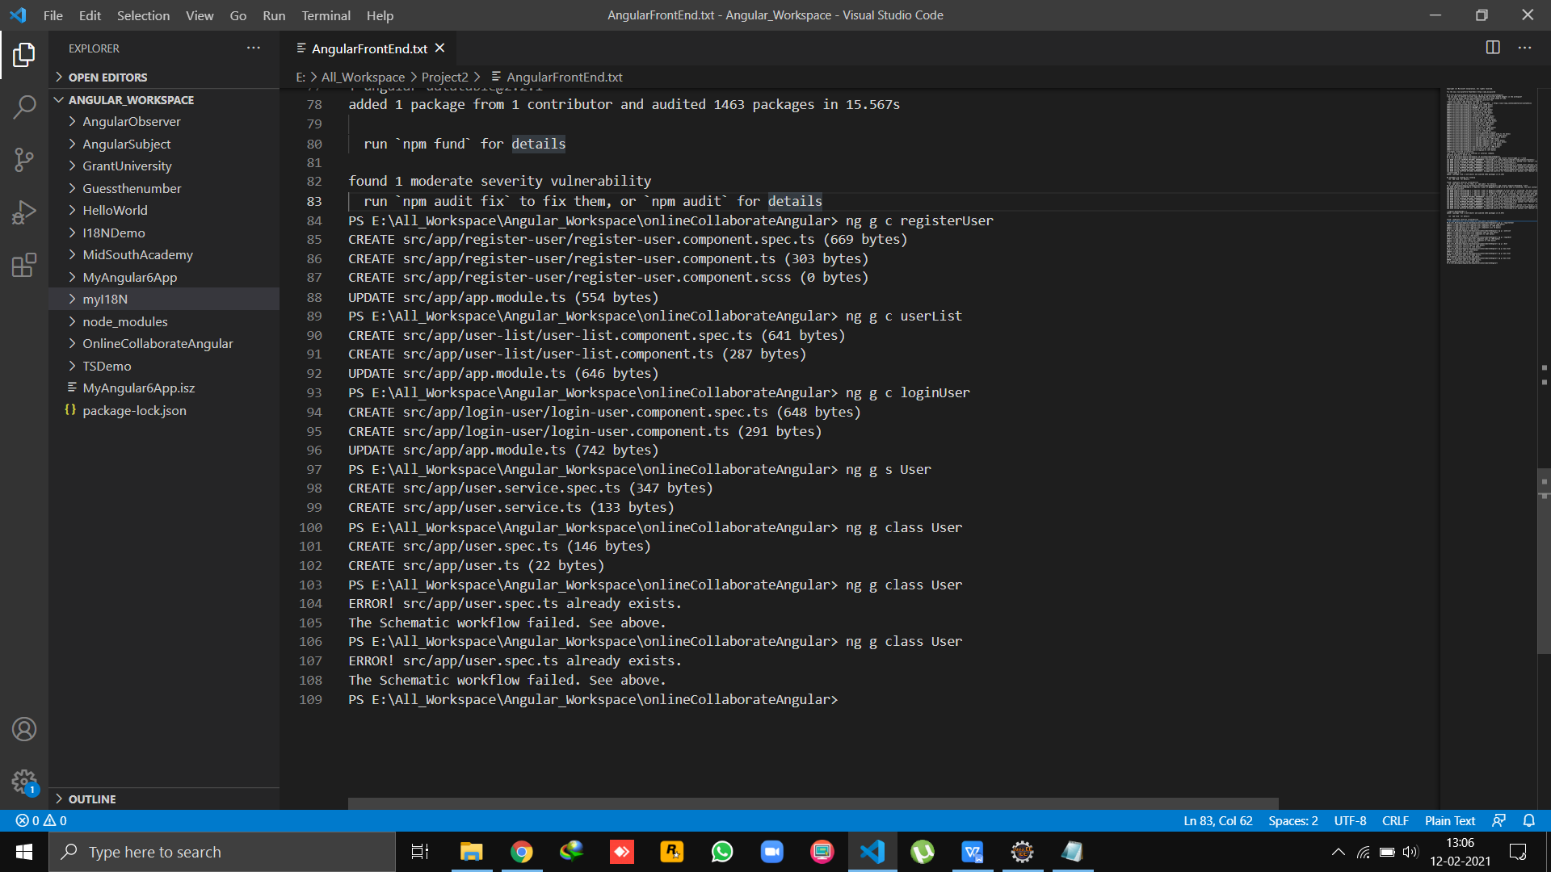





1. Let's also create a service class by using the following command: -

ng g s User



1. Edit the **app.module.ts** file
   1. **Import Routing** - Here, we are importing routing file (app-routing.module.ts) and include it in imports array.
   2. **Import ReactiveFormsModule** - Here, we are importing **ReactiveFormsModule** for reactive forms and specify it in imports array.
   3. **Import HttpModule** - Here, we are importing **HttpModule** for server requests and specifying it in imports array.
   4. **Register Service class** - Here, we are mentioning the service class in provider's array.

**//app.module.ts**

import { BrowserModule } from '@angular/platform-browser';

import { NgModule } from '@angular/core';

import { FormsModule, ReactiveFormsModule } from '@angular/forms';

import { HttpClientModule } from '@angular/common/http';

import {DataTablesModule } from 'angular-datatables';

import { AppRoutingModule } from './app-routing.module';

import { AppComponent } from './app.component';

import { RegisterUserComponent } from './register-user/register-user.component';

import { UserListComponent } from './user-list/user-list.component';

import { LoginUserComponent } from './login-user/login-user.component';

import { BrowserAnimationsModule } from '@angular/platform-browser/animations';

import { NavigationComponent } from './navigation/navigation.component';

import { LayoutModule } from '@angular/cdk/layout';

import { MatToolbarModule } from '@angular/material/toolbar';

import { MatButtonModule } from '@angular/material/button';

import { MatSidenavModule } from '@angular/material/sidenav';

import { MatIconModule } from '@angular/material/icon';

import { MatListModule } from '@angular/material/list';

import { UserProfileComponent } from './user-profile/user-profile.component';

import { BlogListComponent } from './blog-list/blog-list.component';

import { ActiveUserComponent } from './active-user/active-user.component';

import { HomeComponent } from './home/home.component';

import { NavigationUserComponent } from './navigation-user/navigation-user.component';

import { AboutUsComponent } from './about-us/about-us.component';

import { EditorModule } from '@tinymce/tinymce-angular';

import { DeactivateUserComponent } from './deactivate-user/deactivate-user.component';

import { AddPostComponent } from './add-post/add-post.component';

import {MatProgressBarModule} from "@angular/material/progress-bar";

import { UpdateUserprofileComponent } from './update-userprofile/update-userprofile.component';

@NgModule({

declarations: [

AppComponent,

RegisterUserComponent,

UserListComponent,

LoginUserComponent,

NavigationComponent,

UserProfileComponent,

BlogListComponent,

ActiveUserComponent,

HomeComponent,

NavigationUserComponent,

AboutUsComponent,

DeactivateUserComponent,

AddPostComponent,

UpdateUserprofileComponent, ],

imports: [

BrowserModule,

AppRoutingModule,

FormsModule,

ReactiveFormsModule,

HttpClientModule,

EditorModule,

MatProgressBarModule,

DataTablesModule, BrowserAnimationsModule, LayoutModule, MatToolbarModule, MatButtonModule, MatSidenavModule, MatIconModule, MatListModule],

providers: [],

bootstrap: [AppComponent]

})

export class AppModule { }

19 . Edit the **app-routing.module.ts** file

import { NgModule } from '@angular/core';

import { Routes, RouterModule } from '@angular/router';

import { RegisterUserComponent } from './register-user/register-user.component';

import { UserListComponent } from './user-list/user-list.component';

import { LoginUserComponent } from './login-user/login-user.component';

import {ActiveUserComponent} from './active-user/active-user.component';

import {BlogListComponent } from './blog-list/blog-list.component';

import {UserProfileComponent} from './user-profile/user-profile.component';

import { HomeComponent } from './home/home.component';

import { NavigationComponent } from './navigation/navigation.component';

import { NavigationUserComponent } from './navigation-user/navigation-user.component';

import { AboutUsComponent } from './about-us/about-us.component';

import { DeactivateUserComponent } from './deactivate-user/deactivate-user.component';

import { AddPostComponent } from './add-post/add-post.component';

const routes: Routes = [

{ path: '', redirectTo: 'home', pathMatch: 'full' },

{path:'home', component: HomeComponent},

{path: 'about-us',component:AboutUsComponent},

{path:'nav/:Id', component:NavigationComponent,

children: [

{ path: 'user-list', component: UserListComponent },

{ path: 'active-user' , component: ActiveUserComponent},

{ path: 'deactivate-user' , component: DeactivateUserComponent},

{ path: 'blog-list' , component: BlogListComponent},

{ path: 'user-profile/:Id' , component: UserProfileComponent}

]

} ,

{path:'nav-user/:Id', component:NavigationUserComponent,

children:[

{ path: 'add-post' , component: AddPostComponent},

{ path: 'blog-list' , component: BlogListComponent},

{ path: 'user-profile/:Id' , component: UserProfileComponent},

]

},

{ path: 'register-user', component: RegisterUserComponent },

{ path: 'login-user' , component: LoginUserComponent} ,];

@NgModule({

imports: [RouterModule.forRoot(routes)],

exports: [RouterModule]

})

export class AppRoutingModule { }

20 .Edit the **app.component.html** file(remove existing code and replace with following code)

<router-outlet>

</router-outlet>

app.component.specs.ts

import { TestBed } from '@angular/core/testing';

import { RouterTestingModule } from '@angular/router/testing';

import { AppComponent } from './app.component';

describe('AppComponent', () => {

beforeEach(async () => {

await TestBed.configureTestingModule({

imports: [

RouterTestingModule

],

declarations: [

AppComponent

],

}).compileComponents();

});

it('should create the app', () => {

const fixture = TestBed.createComponent(AppComponent);

const app = fixture.componentInstance;

expect(app).toBeTruthy();

});

it(`should have as title 'OnlineCollaborateAngular'`, () => {

const fixture = TestBed.createComponent(AppComponent);

const app = fixture.componentInstance;

expect(app.title).toEqual('OnlineCollaborateAngular');

});

it('should render title', () => {

const fixture = TestBed.createComponent(AppComponent);

fixture.detectChanges();

const compiled = fixture.nativeElement;

expect(compiled.querySelector('.content span').textContent).toContain('OnlineCollaborateAngular app is running!');

});

});

21 .Create the **User.ts** class

Let's create a class by using the following command: -

*ng g class User*



22 . Now, specify the required fields within the **User** class. (The purpose of this class is to map the specified fields with the fields of Spring entity class.)

export class User {

user_id!: number;

first_name!: String;

last_name!: String;

username!: String;

password!: String;

confirm_password!: String;

email!: String;

role!: String;

status!: String;

isOnline!: boolean;

enabled!: boolean;

}

23 . Edit the **User**.service.ts****file

import { Injectable } from '@angular/core';

import { HttpClient } from '@angular/common/http';

import { Observable } from 'rxjs';

@Injectable({

providedIn: 'root'

})

export class UserService {

private baseUrl = 'http://localhost:8080/api/';

constructor(private http:HttpClient) {

}

getUserList(): Observable<any> {

return this.http.get(`${this.baseUrl}`+'user-list');

}

createUser(user: object): Observable<object> {

return this.http.post(`${this.baseUrl}`+'save-user', user);

}

deleteUser(userId: number): Observable<any> {

return this.http.delete(`${this.baseUrl}/delete-user/${userId}`, { responseType: 'text' });

}

getUser(userId: number): Observable<Object> {

return this.http.get(`${this.baseUrl}/user/${userId}`);

}

updateUser(userId: number, value: any): Observable<Object> {

return this.http.post(`${this.baseUrl}/update-user/${userId}`, value);

}

deactiveList():Observable<any> {

return this.http.get(`${this.baseUrl}`+'deactive-list');

}

activeUser(userId: number): Observable<Object> {

return this.http.post(`${this.baseUrl}/active-user/${userId}`, {responseType: 'text'});

}

checkUser(user: object): Observable<any> {

return this.http.post(`${this.baseUrl}`+"validate-user", user);

}

logoutUser(userId: number): Observable<Object> {

return this.http.post(`${this.baseUrl}/logout-user/${userId}`, {responseType: 'text'});

}

updateUserProfile(userId: number, value: any): Observable<Object> {

return this.http.post(`${this.baseUrl}/update-userprofile/${userId}`, value);

}

}

24 .Edit the **register-user**.component.ts****file

import { Component, OnInit } from '@angular/core';

import { UserService } from '../user.service';

import {FormControl,FormGroup,Validators} from '@angular/forms';

import { User } from '../user';

@Component({

selector: 'app-register-user',

templateUrl: './register-user.component.html',

styleUrls: ['./register-user.component.scss']

})

export class RegisterUserComponent implements OnInit {

constructor(private userservice:UserService) { }

user : User=new User();

submitted = false;

ngOnInit(): void {

this.submitted=false;

}

registrationform=new FormGroup({

firstName:new FormControl('' , [Validators.required ] ),

lastName:new FormControl('' , [Validators.required ] ),

username:new FormControl('' , [Validators.required ] ),

password:new FormControl('' , [Validators.required ] ),

confirm_password:new FormControl('' , [Validators.required ] ),

email:new FormControl('',[Validators.required,Validators.email]),

role:new FormControl()

});

register()

{

this.user=new User();

this.user.firstName=this.FirstName!.value;

this.user.lastName=this.LastName!.value;

this.user.username=this.Username!.value;

if(this.Password!.value===this.ConfirmPassword!.value)

this.user.password=this.Password!.value;

this.user.email=this.Email!.value;

this.user.role=this.Role!.value;

if(this.user.role==="Admin"){

this.user.enabled="true";

this.user.status="Active";

}

else{

this.user.enabled="false";

this.user.status="Inactive";

}

this.user.isOnline="false";

this.submitted = true;

console.log(this.user.firstName);

this.save();

}

save() {

this.userservice.createUser(this.user)

.subscribe(data => console.log(data), error => console.log(error));

this.user = new User();

}

get FirstName(){

return this.registrationform.get('firstName');

}

get LastName(){

return this.registrationform.get('lastName');

}

get Username(){

return this.registrationform.get('username');

}

get Password(){

return this.registrationform.get('password');

}

get ConfirmPassword(){

return this.registrationform.get('confirm_password');

}

get Email(){

return this.registrationform.get('email');

}

get Role(){

return this.registrationform.get('role');

}

registrationForm(){

this.submitted=false;

this.registrationform.reset();

}

logInUser() {

$(".pages").css("visibility","visible");

$(".peru").css("visibility","hidden");

}

}

25 . Edit the **register-user**.component.html**** file

<h3 style="text-align: center">Register User</h3>

<div class="row">

<div class="col-sm-4"></div>

<div class="col-sm-4" >

<div [hidden]="submitted" style="width: 400px;">

<form [formGroup]="registrationform" (ngSubmit)="register()">

<div class="form-group">

<label for="firstName">First Name</label>

<input type="text" class="form-control" formControlName="firstName" data-toggle="tooltip"

data-placement="right" title="Enter First Name" placeholder="Enter Your FirstName">

<div class="alert alert-danger" *ngIf = "(FirstName.touched) && (FirstName.invalid)"

style="margin-top: 5px;">

<span *ngIf="FirstName.errors.required">First Name is Required</span>

<span *ngIf = "FirstName.errors.minlength">

MinLength Error

</span>

</div>

</div>

<div class="form-group">

<label for="lastName">Last Name</label>

<input type="text" class="form-control" formControlName="lastName" data-toggle="tooltip"

data-placement="right" title="Enter Last Name" placeholder="Enter Your LastName">

<div class="alert alert-danger" *ngIf = "(LastName.touched) && (LastName.invalid)"

style="margin-top: 5px;">

<span *ngIf="LastName.errors.required">LastName is Required</span>

<span *ngIf = "LastName.errors.minlength">

MinLength Error

</span>

</div>

</div>

<div class="form-group">

<label for="username">Username</label>

<input type="text" class="form-control" formControlName="username" data-toggle="tooltip"

data-placement="right" title="Enter Username" placeholder="Enter Your Username">

<div class="alert alert-danger" *ngIf = "(Username.touched) && (Username.invalid)"

style="margin-top: 5px;">

<span *ngIf="Username.errors.required">Username is Required</span>

<span *ngIf = "Username.errors.minlength"> MinLength Error </span>

</div>

</div>

<div class="form-group">

<label for="password">Password</label>

<input type="password" class="form-control" formControlName="password" data-toggle="tooltip"

data-placement="right" title="Enter Password" placeholder="Enter Your Password">

<div class="alert alert-danger" *ngIf = "(Password.touched) && (Password.invalid)"

style="margin-top: 5px;">

<span *ngIf="Password.errors.required">Password is Required</span>

<span *ngIf = "Password.errors.minlength"> MinLength Error </span>

</div>

</div>

<div class="form-group">

<label for="confirm_password">Confirm Password</label>

<input type="password" class="form-control" formControlName="confirm_password" data-toggle="tooltip"

data-placement="right" title="Enter Confirm Password" placeholder="Enter Your Confirm Password">

<div class="alert alert-danger" *ngIf = "(ConfirmPassword.touched) && (ConfirmPassword.invalid)"

style="margin-top: 5px;">

<span *ngIf="ConfirmPassword.errors.required">Confirm Password is Required</span>

<span *ngIf="ConfirmPassword.errors.pattern">Password and Confirm Password does not match.</span>

<span *ngIf = "ConfirmPassword.errors.minlength"> MinLength Error </span>

</div>

</div>

<div class="form-group">

<label for="email">Email</label>

<input type="text" class="form-control" formControlName="email"

data-toggle="tooltip" data-placement="right" title="Enter Email Id" placeholder="Enter Your Email Id">

<div class="alert alert-danger" *ngIf = "(Email.touched) && (Email.invalid)"

style="margin-top: 5px;">

<span *ngIf="Email.errors.required">Email is Required</span>

<span *ngIf = "Email.errors.email">

Invalid Email Format

</span>

</div>

</div>

<div class="form-group">

<label for="role">Role</label>

<select class="form-control" formControlName="role" data-toggle="tooltip"

data-placement="right" title="Select Role" >

<option value="null">--User Role--</option>

<option value="Admin">Admin</option>

<option value="User">User</option>

</select>

</div>

<button type="submit" class="btn btn-success">Submit</button>

</form>

</div>

</div>

</div>

<div [hidden]="!submitted">

<h4 style="font-weight: bold; font-style: italic; text-align: center; color:green;">Congratulations..!!! You have Registered successFully..!!</h4>

</div>

Edit the **register-user**.component.scss**** file

body {

margin: 0;

padding: 0;

font-family: sans-serif;

background: linear-gradient(to right, #b92b27, #1565c0)

}

.row {

width: 300px;

left: 150%;

padding: 20px;

position:relative;

text-align:center;

transition: 0.25s;

margin-top: 125px

}

.row input[type="text"],

.row input[type="password"],

.row select {

border: 0;

background: none;

display: block;

margin: 10px auto;

text-align: center;

border: 3px solid #3498db;

padding: 5px 10px;

width: 200px;

outline: none;

color: white;

border-radius: 25px;

transition: 0.25s

}

.row label{

color:aliceblue;

}

.row h2,h4 {

color: white;

text-transform: uppercase;

font-weight: 500;

}

.row label:hover{

color: yellow;

}

.row h2:hover{

color:yellow;

}

.row a{

color:white;

}

.row a:hover{

color:palegoldenrod;

}

.row input[type="text"]:focus,

.row input[type="password"]:focus,

.row select:focus {

width: 300px;

border-color: #2ecc71

}

.row option{

background-color:black;

}

.row button[type="submit"] {

border: 0;

background: none;

display: block;

margin: 20px auto;

text-align: center;

border: 2px solid #2ecc71;

padding: 14px 40px;

outline: none;

color: white;

border-radius: 24px;

transition: 0.25s;

cursor: pointer

}

.row

button[type="submit"]:hover {

background:rebeccapurple

}

::placeholder {

color:white;

opacity: 1; /* Firefox */

}

:-ms-input-placeholder { /* Internet Explorer 10-11 */

color:white;

}

::-ms-input-placeholder { /* Microsoft Edge */

color:white;

}

.pages{

position:absolute;

top:10%;

left:10%;

visibility: hidden;

}

.form-control{

width:100%;

border-radius:5px;

border: 2px solid rgba(76, 46, 207, 0.856);

font-size: 13px;

font-family:monospace;

}

26 .Edit the**user**-list.component.ts****file

import { Component, OnInit } from '@angular/core';

import { UserService } from '../user.service';

import { User } from '../user';

import { Observable, Subject } from 'rxjs';

import { Validators, FormControl, FormGroup, FormBuilder } from '@angular/forms';

import { DataTablesModule } from 'angular-datatables';

@Component({

selector: 'app-user-list',

templateUrl: './user-list.component.html',

styleUrls: ['./user-list.component.scss']

})

export class UserListComponent implements OnInit {

constructor(private userservice: UserService) { }

userArray: any[] = [];

dtOptions: DataTables.Settings = {};

dtTrigger: Subject<any> = new Subject();

users:any;

user: User = new User();

deleteMessage = false;

userlist: any;

isupdated = false;

ngOnInit() {

this.isupdated = false;

this.dtOptions = {

pageLength: 6,

stateSave: true,

lengthMenu: [[6, 16, 20, -1], [6, 16, 20, "All"]],

processing: true

};

this.userservice.getUserList().subscribe((data) => {

this.users = data;

this.dtTrigger.next();

})

}

deleteUser(userId: number) {

this.userservice.deleteUser(userId)

.subscribe(

(data) => {

console.log(data);

this.deleteMessage = true;

this.userservice.getUserList().subscribe((data) => {

this.users = data

})

},

(error) => console.log(error));

}

updatUser(id: number) {

this.userservice.getUser(id)

.subscribe(

(data) => {

this.userlist = data;

console.log(this.userlist);

}),

(error:any) => console.log(error);

}

userupdateform = new FormGroup({

userId: new FormControl(),

firstName: new FormControl(),

lastName: new FormControl(),

username: new FormControl(),

password: new FormControl(),

email: new FormControl(),

role: new FormControl(),

status: new FormControl(),

isOnline: new FormControl(),

enabled: new FormControl()

});

updateUser(updateusers: any) {

this.user = new User();

this.user.userId = this.UserId!.value;

this.user.firstName = this.FirstName!.value;

this.user.lastName = this.LastName!.value;

this.user.username = this.UserName!.value;

this.user.password = this.Password!.value;

this.user.email = this.Email!.value;

this.user.role = this.Role!.value;

this.user.status = this.Status!.value;

this.user.isOnline = this.IsOnline!.value;

this.user.enabled = this.Enabled!.value;

console.log(this.FirstName!.value);

this.userservice.updateUser(this.user.userId, this.user).subscribe(

data => {

this.isupdated = true;

this.userservice.getUserList().subscribe(data => {

this.users = data

})

},

error => {

console.log(this.users);

console.log(error)});

}

get FirstName() {

return this.userupdateform.get('firstName');

}

get LastName() {

return this.userupdateform.get('lastName');

}

get UserName() {

return this.userupdateform.get('username');

}

get Password() {

return this.userupdateform.get('password');

}

get Email() {

return this.userupdateform.get('email');

}

get Role() {

return this.userupdateform.get('role');

}

get Status() {

return this.userupdateform.get('status');

}

get IsOnline() {

return this.userupdateform.get('isOnline');

}

get Enabled() {

return this.userupdateform.get('enabled');

}

get UserId() {

return this.userupdateform.get('userId');

}

changeisUpdate() {

this.isupdated = false;

}

}

27 . Edit the **user**-list.component.html****file

<div class="panel">

<div class="panel panel-default">

<div class="panel-heading">

<h1 style="font-weight: bold; font-style: italic; text-align: center; ">Users</h1><br>

<div class="row" [hidden]="!deleteMessage">

<div class="col-sm-4"></div>

<div class="col-sm-4">

<div class="alert alert-info alert-dismissible">

<button type="button" class="close" data-dismiss="alert">×</button>

<strong>User Data Deleted</strong>

</div>

</div>

<div class="col-sm-4"></div>

</div>

</div>

<div class="panel-body">

<table class="table table-hover table-sm" datatable [dtOptions]="dtOptions" [dtTrigger]="dtTrigger">

<thead class="thead-light">

<tr>

<th>UserID</th>

<th>FirstName</th>

<th>LastName</th>

<th>UserName</th>

<th>Email</th>

<th>Role</th>

<th>Status</th>

<th>IsOnline</th>

<th>Enabled</th>

<th>Action</th>

</tr>

</thead>

<tbody>

<tr *ngFor="let user of users">

<td>{{user.userId}}</td>

<td>{{user.firstName}}</td>

<td>{{user.lastName}}</td>

<td>{{user.username}}</td>

<td>{{user.email}}</td>

<td>{{user.role}}</td>

<td>{{user.status}}</td>

<td>{{user.isOnline}}</td>

<td>{{user.enabled}}</td>

<td><button (click)="deleteUser(user.userId)" class='btn btn-primary'><i class="fa fa-futboll-0">Delete</i></button> &nbsp; &nbsp;

<button (click)="updatUser(user.userId)" class='btn btn-info' data-toggle="modal"

data-target="#myModal">Update</button>

</td>

</tr>

</tbody><br>

</table>

</div>

</div>

</div>

<div class="modal" id="myModal">

<div class="modal-dialog">

<div class="modal-content">

<form [formGroup]="userupdateform" #updateusers (ngSubmit)="updateUser(updateusers)">

<!-- Modal Header -->

<div class="modal-header">

<h4 class="modal-title" style="text-align: center">Update User</h4>

</div>

<!-- Modal body -->

<div class="modal-body" *ngIf="userlist">

<div [hidden]="isupdated">

<input type="hidden" class="form-control" formControlName="userId" [(ngModel)]="userlist.userId">

<div class="form-group">

<label for="name">First Name</label>

<input type="text" class="form-control" formControlName="firstName" [(ngModel)]="userlist.firstName">

</div>

<div class="form-group">

<label for="name">Last Name</label>

<input type="text" class="form-control" formControlName="lastName" [(ngModel)]="userlist.lastName">

</div>

<div class="form-group">

<label for="name">Username</label>

<input type="text" class="form-control" formControlName="username" [(ngModel)]="userlist.username">

</div>

<div class="form-group">

<label for="name">Password</label>

<input type="password" class="form-control" formControlName="password" [(ngModel)]="userlist.password">

</div>

<div class="form-group">

<label for="name">Email</label>

<input type="text" class="form-control" formControlName="email" [(ngModel)]="userlist.email">

</div>

<div class="form-group">

<label for="name">Role</label>

<select class="form-control" formControlName="role" required>

<option value="Admin" [selected]="'Admin' == userlist.role">Admin</option>

<option value="User" [selected]="'User' == userlist.role">User</option>

</select>

</div>

<div class="form-group">

<label for="name">Status</label>

<input type="text" class="form-control" formControlName="status" [(ngModel)]="userlist.status">

</div>

<div class="form-group">

<label for="name">IsOnline</label>

<input type="text" class="form-control" formControlName="isOnline" [(ngModel)]="userlist.isOnline">

</div>

<div class="form-group">

<label for="name">Enabled</label>

<input type="text" class="form-control" formControlName="enabled" [(ngModel)]="userlist.enabled">

</div>

</div>

<div [hidden]="!isupdated">

<h4>User Detail Updated!</h4>

</div>

</div>

<!-- Modal footer -->

<div class="modal-footer">

<button type="submit" class="btn btn-success" [hidden]="isupdated">Update</button>

<button type="button" class="btn btn-danger" data-dismiss="modal" (click)="changeisUpdate()">Close</button>

</div>

</form>

</div>

</div>

</div>

Edit the **user**-list.component.scss****file

.panel{

position:relative;

left:95px;

background-color:lightskyblue;

}

td {

border-right: solid 0.5px rgb(10, 10, 10);

border-bottom:solid 0.5px black;

}

th{

border-top:solid 0.5px black;

border-bottom:solid 0.5px black; ;

}

.panel th:hover{

color:white;

}

.panel tr:hover{

font-weight: bold;

color:blue;

}

.panel button:hover{

font-weight: bolder;

color:black;

}

.panel td:nth-child(1n+1):hover{

color:black;

}

28 **. Install following:**

npm install jquery --save

npm install datatables.net --save

npm install datatables.net-dt --save

npm install angular-datatables@6.0.0 --save

npm install @types/jquery --save-dev

npm install @types/datatables.net --save-dev

29 .**Edit angular.json file at line 30. styles and scripts:**

"styles": [

"src/styles.scss",

"node_modules/datatables.net-dt/css/jquery.dataTables.css",

"node_modules/bootstrap/dist/css/bootstrap.css"

],

"scripts": [

"node_modules/jquery/dist/jquery.js",

"node_modules/datatables.net/js/jquery.dataTables.js",

"node_modules/bootstrap/dist/js/bootstrap.js"

]

30.**Save All.**

31.**Run the SpringBoot Application**

32.**Run the Angular project**

**Login -User Component**

**Login-user.component.ts**

import { Component, OnInit } from '@angular/core';

import { UserService } from '../user.service';

import { User } from '../user';

import { Observable, Subject } from 'rxjs';

import { Validators, FormControl, FormGroup, FormBuilder } from '@angular/forms';

import { DataTablesModule } from 'angular-datatables';

import { Router } from '@angular/router';

@Component({

selector: 'app-login-user',

templateUrl: './login-user.component.html',

styleUrls: ['./login-user.component.scss']

})

export class LoginUserComponent implements OnInit {

user : User=new User();

currentUser : any;

constructor(private userService: UserService, private router: Router) { }

ngOnInit(): void {

}

loginform=new FormGroup({

username:new FormControl('',[Validators.required]),

password:new FormControl('',[Validators.required])

})

validateUser() {

this.user=new User();

this.user.username=this.Username?.value;

this.user.password=this.Password?.value;

this.userService.checkUser(this.user).subscribe (

data => {

console.log(data);

if(data!=null) {

this.currentUser=data;

if(this.currentUser.role==="Admin"){

this.router.navigateByUrl("/nav/" +`${this.currentUser.userId}`);

}

else{

this.router.navigateByUrl("/nav-user/"+`${this.currentUser.userId}`);

}

}

else {

console.log("Object Empty");

}

},

error => console.log(error)

)

}

get Username() {

return this.loginform.get ('username');

}

get Password() {

return this.loginform.get ('password');

}

RegUser(){

$(".pagess").css("visibility","visible");

$(".card").css("visibility","hidden");

}

}

**Login-user.component.html**

<div class="login-box">

<h2>Login</h2>

<form [formGroup]="loginform" (ngSubmit)="validateUser()">

<!--Username-->

<div class="user-box">

<input type="text" class="form-control" formControlName="username" data-toggle="tooltip"

data-placement="right" title="Enter Username" placeholder="Username">

<div class="alert alert-danger" *ngIf = "(Username.touched) && (Username.invalid)"

style="margin-top: 5px;">

<span *ngIf="Username.errors.required">Username is Required</span>

</div>

</div>

<!--Password-->

<div class="user-box">

<input type="password" class="form-control" formControlName="password" data-toggle="tooltip"

data-placement="right" title="Enter Password" placeholder="Password">

<div class="alert alert-danger" *ngIf = "(Password.touched) && (Password.invalid)"

style="margin-top: 5px;">

<span *ngIf="Password.errors.required">Password is Required</span>

</div>

</div>

<button type="submit" class="btn btn-success">Submit</button>

</form>

</div>

**Login-user.component.scss**

html {

height: 100%;

}

body {

margin:0;

padding:0;

font-family: sans-serif;

background: linear-gradient(#141e30, #243b55);

}

.login-box {

position:fixed;

top: 50%;

right: 50%;

width: 400px;

padding: 40px;

transform: translate(-50%, -50%);

background: rgba(6, 1, 31, 0.938);

box-sizing: border-box;

box-shadow: 0 15px 25px rgba(0,0,0,.6);

border-radius: 20px;

}

.login-box h2 {

margin: 0 0 30px;

padding: 0;

color: #fff;

text-align: center;

}

.login-box .user-box {

position: relative;

}

.login-box .user-box input {

width: 100%;

padding: 10px 0;

font-size: 16px;

color: #fff;

margin-bottom: 30px;

border: none;

border-bottom: 1px solid #fff;

outline: none;

background: transparent;

}

.login-box .user-box label {

position: absolute;

top:0;

left: 0;

padding: 10px 0;

font-size: 16px;

color: #fff;

pointer-events: none;

transition: .5s;

}

.login-box .user-box input:focus ~ label,

.login-box .user-box input:valid ~ label {

top: -20px;

left: 0;

color: #03e9f4;

font-size: 12px;

}

.login-box form a {

position: relative;

display: inline-block;

padding: 10px 20px;

color: #03e9f4;

font-size: 16px;

text-decoration: none;

text-transform: uppercase;

overflow: hidden;

transition: .5s;

margin-top: 40px;

letter-spacing: 4px

}

.login-box a:hover {

background: #03e9f4;

color: #fff;

border-radius: 5px;

box-shadow: 0 0 5px #03e9f4,

0 0 25px #03e9f4,

0 0 50px #03e9f4,

0 0 100px #03e9f4;

}

.login-box a span {

position: absolute;

display: block;

}

.login-box a span:nth-child(1) {

top: 0;

left: -100%;

width: 100%;

height: 2px;

background: linear-gradient(90deg, transparent, #03e9f4);

animation: btn-anim1 1s linear infinite;

}

@keyframes btn-anim1 {

0% {

left: -100%;

}

50%,100% {

left: 100%;

}

}

.login-box a span:nth-child(2) {

top: -100%;

right: 0;

width: 2px;

height: 100%;

background: linear-gradient(180deg, transparent, #03e9f4);

animation: btn-anim2 1s linear infinite;

animation-delay: .25s

}

@keyframes btn-anim2 {

0% {

top: -100%;

}

50%,100% {

top: 100%;

}

}

.login-box a span:nth-child(3) {

bottom: 0;

right: -100%;

width: 100%;

height: 2px;

background: linear-gradient(270deg, transparent, #03e9f4);

animation: btn-anim3 1s linear infinite;

animation-delay: .5s

}

@keyframes btn-anim3 {

0% {

right: -100%;

}

50%,100% {

right: 100%;

}

}

.login-box a span:nth-child(4) {

bottom: -100%;

left: 0;

width: 2px;

height: 100%;

background: linear-gradient(360deg, transparent, #03e9f4);

animation: btn-anim4 1s linear infinite;

animation-delay: .75s

}

@keyframes btn-anim4 {

0% {

bottom: -100%;

}

50%,100% {

bottom: 100%;

}

}

**Active User Component**

**Active-user.component.ts**

import { Component, OnInit } from '@angular/core';

import { UserService } from '../user.service';

import { User } from '../user';

import { Observable, Subject } from 'rxjs';

import { Validators, FormControl, FormGroup, FormBuilder } from '@angular/forms';

import { DataTablesModule } from 'angular-datatables';

@Component({

selector: 'app-active-user',

templateUrl: './active-user.component.html',

styleUrls: ['./active-user.component.scss']

})

export class ActiveUserComponent implements OnInit {

dtOptions: DataTables.Settings={};

dtTrigger: Subject<any>= new Subject();

constructor(private userservice: UserService) { }

users:any;

user: User =new User();

deactiveList: any;

isEnabled= false;

ngOnInit(){

this.isEnabled= false;

this.dtOptions={

pageLength: 6,

stateSave: true,

lengthMenu: [[6, 16, 20, -1], [6, 16, 20, "All"]],

processing: true

};

this.userservice.deactiveList().subscribe(data =>{

this.users =data;

this.dtTrigger.next();

})

}

enabledUser(id: number){

this.userservice.activeUser(id).

subscribe(

(data) =>{

this.deactiveList =data;

console.log(this.deactiveList);

this.activeUser(id);

},

(error) => console.log(error)

);

}

activeUserForm = new FormGroup({

userId: new FormControl()

});

activeUser(id:number){

this.user =new User();

this.user.userId=id;

this.userservice.activeUser(this.user.userId).subscribe(

data => {

this.userservice.deactiveList().subscribe( data =>{

this.users =data

console.log(this.users)

} )

},

error => console.log(error));

}

get UserId() {

return this.activeUserForm.get('userId');

}

}

**Active-user.component.html**

<h1 style="font-weight: bold; font-style: italic; text-align: center; ">Users Deactive List</h1><br>

<div class="panel">

<div class="panel panel-default">

<div class="row" [hidden]="!isEnabled">

<div class="col-sm-4">

<div class="alert alert-info alert-dismissible">

<button type="button" class="close" data-dismiss="alert">×</button>

<h2 style="text-align: center; font-weight: bold;">User Activated</h2>

</div>

</div>

</div>

<div class="panel-body">

<table class="table tabele-hover table-sm" datatable [dtOptions]="dtOptions" [dtTrigger]="dtTrigger">

<thead class="thead-light">

<tr>

<th>UserID</th>

<th>Name</th>

<th>UserName</th>

<th>Enabled</th>

</tr>

</thead>

<tbody>

<tr *ngFor="let user of users">

<td>{{user.userId}}</td>

<td>{{user.firstName }}</td>

<td>{{user.username}}</td>

<td>{{user.enabled}}</td>

<td> <button (click)="enabledUser(user.userId)" class='btn btn-info' data-toggle="modal"

data-target="#myModal">Activate</button> &nbsp; &nbsp;</td>

</tr>

</tbody>

</table>

</div>

</div>

</div>

**Active-user.component.scss**

.panel{

position:relative;

left:95px;

background-color:lightskyblue;

}

td {

border-right: solid 0.3px rgb(10, 10, 10);

border-bottom:solid 0.3px black;

}

th{

border-top:solid 0.5px black;

border-bottom:solid 0.5px black; ;

}

.panel-body th:hover{

color:white;

}

.panel-body tr:hover{

font-weight: bold;

color:blue;

}

.panel button:hover{

font-weight: bolder;

color:black;

}

.panel-body td:nth-child(1n+1):hover{

color:black;

}

**Deactivate User Component**

**Deactivate-user.component.ts**

import { Component, OnInit } from '@angular/core';

import { UserService } from '../user.service';

import { User } from '../user';

import { Observable, Subject } from 'rxjs';

import { Validators, FormControl, FormGroup, FormBuilder } from '@angular/forms';

import { DataTablesModule } from 'angular-datatables';

@Component({

selector: 'app-deactivate-user',

templateUrl: './deactivate-user.component.html',

styleUrls: ['./deactivate-user.component.scss']

})

export class DeactivateUserComponent implements OnInit {

dtOptions: DataTables.Settings={};

dtTrigger: Subject<any>= new Subject();

constructor(private userservice: UserService) { }

users:any;

user: User =new User();

activeList: any;

isEnabled= true;

ngOnInit(){

this.isEnabled= true;

this.dtOptions={

pageLength: 6,

stateSave: true,

lengthMenu: [[6, 16, 20, -1], [6, 16, 20, "All"]],

processing: true

};

this.userservice.activeList().subscribe((data: any) =>{

this.users =data;

this.dtTrigger.next();

})

}

enabledUser(id: number){

this.userservice.deactiveUser(id).

subscribe(

(data: any) =>{

this.activeList =data;

console.log(this.activeList);

this.deactiveUser(id);

},

(error: any) => console.log(error)

);

}

deactiveUserForm = new FormGroup({

userId: new FormControl()

});

deactiveUser(id:number){

this.user =new User();

this.user.userId=id;

this.userservice.deactiveUser(this.user.userId).subscribe(

( data: any) => {

this.userservice.activeList().subscribe( (data: any) =>{

this.users =data

console.log(this.users)

} )

},

( error: any) => console.log(error));

}

get UserId() {

return this.deactiveUserForm.get('userId');

}

}

**Deactivate-user.component.html**

<h1 style="font-weight: bold; font-style: italic; text-align: center; ">Users Deactive List</h1><br>

<div class="panel">

<div class="panel panel-default">

<div class="panel-body">

<table class="table tabele-hover table-sm" datatable [dtOptions]="dtOptions" [dtTrigger]="dtTrigger">

<thead class="thead-light">

<tr>

<th>UserID</th>

<th>Name</th>

<th>UserName</th>

<th>Enabled</th>

</tr>

</thead>

<tbody>

<tr *ngFor="let user of users">

<td>{{user.userId}}</td>

<td>{{user.firstName }}</td>

<td>{{user.username}}</td>

<td>{{user.enabled}}</td>

<td> <button (click)="enabledUser(user.userId)" class='btn btn-info' data-toggle="modal"

data-target="#myModal">Activate</button> &nbsp; &nbsp;</td>

</tr>

</tbody>

</table>

</div>

</div>

</div>

**Deactivate-user.component.scss**

.panel{

position:relative;

left:95px;

background-color:lightskyblue;

}

td {

border-right: solid 0.3px rgb(10, 10, 10);

border-bottom:solid 0.3px black;

}

th{

border-top:solid 0.5px black;

border-bottom:solid 0.5px black; ;

}

.panel-body th:hover{

color:white;

}

.panel-body tr:hover{

font-weight: bold;

color:blue;

}

.panel button:hover{

font-weight: bolder;

color:black;

}

.panel-body td:nth-child(1n+1):hover{

color:black;

}

**Deactivate-user.component.specs.ts**

import { ComponentFixture, TestBed } from '@angular/core/testing';

import { DeactivateUserComponent } from './deactivate-user.component';

describe('DeactivateUserComponent', () => {

let component: DeactivateUserComponent;

let fixture: ComponentFixture<DeactivateUserComponent>;

beforeEach(async () => {

await TestBed.configureTestingModule({

declarations: [ DeactivateUserComponent ]

})

.compileComponents();

});

beforeEach(() => {

fixture = TestBed.createComponent(DeactivateUserComponent);

component = fixture.componentInstance;

fixture.detectChanges();

});

it('should create', () => {

expect(component).toBeTruthy();

});

});

**User-profile component**

**User-profile.component.ts**

import { Component, OnInit } from '@angular/core';

import { UserService } from '../user.service';

import { User } from '../user';

import { Observable, Subject } from 'rxjs';

import { Validators, FormControl, FormGroup, FormBuilder } from '@angular/forms';

import { DataTablesModule } from 'angular-datatables';

import { param } from 'jquery';

import { ActivatedRoute, Params } from '@angular/router';

@Component({

selector: 'app-user-profile',

templateUrl: './user-profile.component.html',

styleUrls: ['./user-profile.component.scss']

})

export class UserProfileComponent implements OnInit {

Id?:number;

user:any;

constructor( private route: ActivatedRoute, private userservice: UserService){ }

ngOnInit(){

this.route.params.subscribe (

(params:Params)=> {

this.Id=+params["Id"];

console.log(this.Id);

this.userservice.getUser(this.Id).subscribe (

data=>{

this.user=data;

console.log(this.user);

}

)

}

)

}

}

**User-profile.component.html**

<div>

<div class="main">

<div class="page-content page-container" id="page-content">

<div class="padding">

<div class="row container d-flex justify-content-center">

<div class="col-xl-6 col-md-12">

<div class="card user-card-full">

<div class="row m-l-0 m-r-0">

<div class="col-sm-4 bg-c-lite-green user-profile">

<div class="card-block text-center text-white">

<div class="m-b-25"> <img src="https://img.icons8.com/bubbles/100/000000/user.png" class="img-radius" alt="User-Profile-Image"> </div>

<h6 class="f-w-600">{{user.username}}</h6>

<p>{{user.role}}</p> <i class=" mdi mdi-square-edit-outline feather icon-edit m-t-10 f-16"></i>

</div>

</div>

<div class="col-sm-8">

<div class="card-block">

<h6 class="m-b-20 p-b-5 b-b-default f-w-600">Information</h6>

<div class="row">

<div class="col-sm-6">

<p class="m-b-10 f-w-600">Name</p>

<h6 class="text-muted f-w-400">{{user.firstName +" "+ user.lastName}}</h6>

</div>

<div class="col-sm-6">

<p class="m-b-10 f-w-600">Email</p>

<h6 class="text-muted f-w-400">{{user.email}}</h6>

</div>

</div>

</div>

</div>

</div>

</div> </div </div> </div>

**User-profile.component.scss**

.main{

position:relative;

left:95px;

}

body {

background-color: #f9f9fa;

position: static;

left:100px;

}

.padding {

padding: 3rem !important

}

.user-card-full {

overflow: hidden

}

h6:hover{

color:blue;

font-weight: bold;

}

p:hover{

color:blue;

font-weight: bold;

}

.card {

border-radius: 5px;

-webkit-box-shadow: 0 1px 20px 0 rgba(69, 90, 100, 0.08);

box-shadow: 0 1px 20px 0 rgba(69, 90, 100, 0.08);

border: none;

margin-bottom: 30px

}

.m-r-0 {

margin-right: 0px

}

.m-l-0 {

margin-left: 0px

}

.user-card-full .user-profile {

border-radius: 5px 0 0 5px

}

.bg-c-lite-green {

background: -webkit-gradient(linear, left top, right top, from(#f29263), to(#ee5a6f));

background: linear-gradient(to right, #ee5a6f, #f29263)

}

.user-profile {

padding: 20px 0

}

.card-block {

padding: 1.25rem

}

.m-b-25 {

margin-bottom: 25px

}

.img-radius {

border-radius: 5px

}

h6 {

font-size: 14px

}

.card .card-block p {

line-height: 25px

}

@media only screen and (min-width: 1400px) {

p {

font-size: 14px

}

}

.card-block {

padding: 1.25rem

}

.b-b-default {

border-bottom: 1px solid #e0e0e0

}

.m-b-20 {

margin-bottom: 20px

}

.p-b-5 {

padding-bottom: 5px !important

}

.card .card-block p {

line-height: 25px

}

.m-b-10 {

margin-bottom: 10px

}

.text-muted {

color: #919aa3 !important

}

.b-b-default {

border-bottom: 1px solid #e0e0e0

}

.f-w-600 {

font-weight: 600

}

.m-b-20 {

margin-bottom: 20px

}

.m-t-40 {

margin-top: 20px

}

.p-b-5 {

padding-bottom: 5px !important

}

.m-b-10 {

margin-bottom: 10px

}

.m-t-40 {

margin-top: 20px

}

.user-card-full .social-link li {

display: inline-block

}

.user-card-full .social-link li a {

font-size: 20px;

margin: 0 10px 0 0;

-webkit-transition: all 0.3s ease-in-out;

transition: all 0.3s ease-in-out

}

**About-us component**

**About-us.component.ts**

import { Component, OnInit } from '@angular/core';

@Component({

selector: 'app-about-us',

templateUrl: './about-us.component.html',

styleUrls: ['./about-us.component.scss']

})

export class AboutUsComponent implements OnInit {

constructor() { }

ngOnInit(): void {

}

}

**About-us.component.html**

<h1 class="logo"><span>Relaxato </span>City</h1>

<html>

<head>

<style>

p {

color: navy;

text-indent: 30px;

text-transform: uppercase;

}

</style>

</head>

<body>

<p style="text-align:center">

Welcome to Relaxato !!!

<br>

Relaxato City is an Photography Blogging Website.

<br>

Here you can share Photos,vlogs

<br>

You can also share your travel experiences with others

</p>

</body>

</html>

About-us.component.scss

.logo{

font-size: 2.5rem; font-weight: 600; text-transform: uppercase;

letter-spacing: 10px; line-height: 4rem; margin-top: 20px;

color:crimson;

}

.logo span{ font-size: 2.5rem;margin-left: 40pc; margin-right: 50px; color:chocolate; }

**Add-post Component**

**Add-post.component.ts**

import { Component, OnInit } from '@angular/core';

import {BlogService} from '../blog.service';

import { Blog } from '../blog';

import { UserService } from '../user.service';

import { Validators, FormControl, FormGroup, FormBuilder } from '@angular/forms';

import { DatePipe, getLocaleDateFormat } from '@angular/common';

import { Observable } from 'rxjs';

import { map, shareReplay } from 'rxjs/operators';

import { ActivatedRoute, Params, Router } from '@angular/router';

import { BreakpointObserver, Breakpoints } from '@angular/cdk/layout';

@Component({

selector: 'app-add-post',

templateUrl: './add-post.component.html',

styleUrls: ['./add-post.component.scss']

})

export class AddPostComponent implements OnInit {

constructor(private blogservice: BlogService,private route: ActivatedRoute, private userservice: UserService) { }

blog: Blog =new Blog();

submitted = false;

user:any;

ngOnInit(): void {

this.submitted = false;

}

addblogform=new FormGroup({

blogTitle:new FormControl('' , [Validators.required ] ),

blogContent:new FormControl('' , [Validators.required ] ),

});

addblog()

{

this.blog=new Blog();

this.blog.blogTitle=this.BlogTitle!.value;

this.blog.blogContent=this.BlogContent!.value;

this.blog.blogPosted=DatePipe;

this.blog.status="false";

this.blog.noOfLikes=0;

this.blog.noOfViews=0;

this.blog.noofComments=0;

this.submitted = true;

this.save();

}

save() {

this.blogservice.createBlog(this.blog)

.subscribe(data => console.log(data), error => console.log(error));

this.blog = new Blog();

}

get BlogTitle(){

return this.addblogform.get('blogTitle');

}

get BlogContent(){

return this.addblogform.get('blogContent');

}

addblogForm(){

this.submitted=false;

this.addblogform.reset();

}

}

**Add-post.component.html**

<div class="add-post-content">

<div class="container">

<div>

<h3 class="new-post-title">Create New Post</h3>

</div>

<hr>

<form [formGroup]="addblogform" (ngSubmit)="addblog()">

<div class="form-group">

<label class="post-title">Title</label>

<input type="text" [formControlName]="'blogTitle'" class="form-control" placeholder="Title">

</div>

<div class="form-group">

<label class="post-content">Body</label>

<editor [formControlName]="'blogContent'" [init]="{plugins: 'link'}"></editor>

</div>

<div class="form-group">

<button type="submit" class="btn btn-primary">Post</button>

</div>

</form >

</div>

</div>

**Add-post.component.scss**

.add-post-content{

padding-top: 20px;

}

.new-post-title{

color: royalblue;

}

.post-content, .post-title{

color: royalblue;

}

**Add-post.component.specs.ts**

import { ComponentFixture, TestBed } from '@angular/core/testing';

import { AddPostComponent } from './add-post.component';

describe('AddPostComponent', () => {

let component: AddPostComponent;

let fixture: ComponentFixture<AddPostComponent>;

beforeEach(async () => {

await TestBed.configureTestingModule({

declarations: [ AddPostComponent ]

})

.compileComponents();

});

beforeEach(() => {

fixture = TestBed.createComponent(AddPostComponent);

component = fixture.componentInstance;

fixture.detectChanges();

});

it('should create', () => {

expect(component).toBeTruthy();

});

});

**Blog Component**

**Blog.ts**

export class Blog{

blogId!:number;

blogTitel!: String;

blogContent!: String;

blogPosted:any;

status!: String;

noOfLikes!: number;

noFoComments!: number;

noOfViews!: number;

userId!: number;

username!: String;

}

**Blog.service.ts**

import { Injectable } from '@angular/core';

import { HttpClient } from '@angular/common/http';

import { Observable } from 'rxjs';

@Injectable({

providedIn: 'root'

})

export class BlogService {

private baseUrl='http://localhost:8080/api/';

constructor(private http:HttpClient){ }

getBlogList(): Observable<any>{

return this.http.get(`${this.baseUrl}`+`blog-list`);

}

createBlog(blog: object): Observable<object>{

return this.http.post(`${this.baseUrl}`+`save-blog`,blog);

}

deletBlog(blogId:number): Observable<any>{

return this.http.delete(`${this.baseUrl}/delete-blog/${blogId}`,{ responseType: 'text' });

}

getBlog(blogId:number): Observable<Object>{

return this.http.get(`${this.baseUrl}/blog/${blogId}`);

}

updateBlog(blogId:number, value:any): Observable<Object>{

return this.http.post(`${this.baseUrl}/update-blog/${blogId}`,value);

}

}

**Blog.service.specs.ts**

import { TestBed } from '@angular/core/testing';

import { BlogService } from './blog.service';

describe('BlogService', () => {

let service: BlogService;

beforeEach(() => {

TestBed.configureTestingModule({});

service = TestBed.inject(BlogService);

});

it('should be created', () => {

expect(service).toBeTruthy();

});

});

**Blog-list.component.ts**

import { Component, OnInit } from '@angular/core';

import {BlogService} from '../blog.service';

import { Blog } from '../blog';

import { Observable, Subject } from 'rxjs';

import { Validators, FormControl, FormGroup, FormBuilder } from '@angular/forms';

import { DataTablesModule } from 'angular-datatables';

@Component({

selector: 'app-blog-list',

templateUrl: './blog-list.component.html',

styleUrls: ['./blog-list.component.scss']

})

export class BlogListComponent implements OnInit {

constructor(private blogservice: BlogService) { }

blog: Blog =new Blog();

submitted = false;

ngOnInit(): void {

this.submitted = false;

}

}

**Blog-list.component.html**

<div class="main">

<div class="container mt-5">

<div class="d-flex justify-content-center row">

<div class="col-md-8">

<div class="d-flex flex-column comment-section">

<div class="bg-white p-2">

<div class="d-flex flex-row user-info">

<div class="d-flex flex-column justify-content-start ml-2"><span class="d-block font-weight-bold name"><strong></strong></span></div>

</div>

<div class="mt-2">

<p class="comment-text"></p>

</div>

</div>

<div class="bg-light p-2">

<div class="d-flex flex-row align-items-start"><textarea class="form-control ml-1 shadow-none textarea"></textarea></div>

<div class="mt-2 text-right"><button class="btn btn-primary btn-sm shadow-none" type="button">Post comment</button><button class="btn btn-outline-primary btn-sm ml-1 shadow-none" type="button">Cancel</button></div>

</div>

</div>

</div>

</div>

</div>

</div>

**Blog-list.component.scss**

body {

background: #eee

}

.main{

position:relative;

left:95px;

background-color:lightskyblue;

}

.date {

font-size: 11px

}

.comment-text {

font-size: 12px

}

.fs-12 {

font-size: 12px

}

.shadow-none {

box-shadow: none

}

.name {

color: #007bff

}

.cursor:hover {

color: blue

}

.cursor {

cursor: pointer

}

.textarea {

resize: none

}

**Blog-list.component.specs.ts**

import { ComponentFixture, TestBed } from '@angular/core/testing';

import { BlogListComponent } from './blog-list.component';

describe('BlogListComponent', () => {

let component: BlogListComponent;

let fixture: ComponentFixture<BlogListComponent>;

beforeEach(async () => {

await TestBed.configureTestingModule({

declarations: [ BlogListComponent ]

})

.compileComponents();

});

beforeEach(() => {

fixture = TestBed.createComponent(BlogListComponent);

component = fixture.componentInstance;

fixture.detectChanges();

});

it('should create', () => {

expect(component).toBeTruthy();

});

});

**Home Component**

**Home.component.ts**

import { Component, OnInit } from '@angular/core';

import { Router } from '@angular/router';

@Component({

selector: 'app-home',

templateUrl: './home.component.html',

styleUrls: ['./home.component.scss']

})

export class HomeComponent implements OnInit {

constructor(private router : Router) { }

ngOnInit(): void {

}

logInUser() {

$(".pages").css("visibility","visible");

}

RegUser(){

$(".pagess").css("visibility","visible");

}

}

**Home.component.html**

<div class="container">

<div class="navbar">

<div class="menu">

<h1 class="logo"><span>Relaxato </span>City</h1>

<div class="bts">

<a href="/about-us" class="about-us">About us</a>

</div>

</div>

</div>

<div class="main-container">

<div class="main">

<header>

<div class="overlay" id="one">

<h2 class="title">Welcome to Relaxato City</h2>

<div class="bts">

<a mat-list-item class="nav-link" (click)="logInUser()" class="btn">Sign In</a>/<a mat-list-item class="nav-link" (click)="RegUser()" class="btn">Sign Up</a>

</div>

</div>

</header>

</div>

<div class="shadow one"></div>

<div class="shadow two"></div>

</div>

</div>

<div class="pages">

<app-login-user></app-login-user>

</div>

<div class="pagess">

<app-register-user></app-register-user>

</div>

**Home.component.scss**

body{ font-family: 'Recursive', sans-serif; overflow: hidden; }

.container{ max-height: 100vh;

width: 100%; background-color: #131414;

background-image: linear-gradient(135deg, #131414 0%, #000000 100%);

transform-style: preserve-3d; overflow: hidden;

}

.navbar{ position: fixed;

top: 0;

left: 0;

width: 100%;

z-index: 10;

height: 5rem;

}

.menu{ max-width: 72rem;

width: 100%;

height: 100%;

margin: 0 auto;

padding: 0 2rem;

display: flex;

justify-content: space-between;

align-items: center;

color: #fff;

}

.logo{

font-size: 2.5rem; font-weight: 600; text-transform: uppercase;

letter-spacing: 10px; line-height: 4rem; margin-top: 20px;

color:darkgoldenrod;

}

.logo span{ font-size: 2.5rem;margin-left: 10pc; margin-right: 50px; color:darkgoldenrod; }

.hamburger-menu{ height: 4rem; width: 3rem; cursor: pointer;

display: flex; align-items: center; justify-content: flex-end; }

.bar{ width: 1.9rem; height: 1.5px; border-radius: 2px;

background-color: #eee; transition: 0.5s; position: relative; }

.bar::before, .bar::after{ content: ""; position: absolute;

width: inherit; height: inherit; background-color: #eee;

transition: 0.5s; }

.bar::before{ transform: translateY(-9px); }

.bar::after{ transform: translateY(9px); }

.main-container{ overflow: hidden; }

.main{ position: relative; width: 100%; left: 0; z-index: 5;

overflow: hidden; transform-origin: left;

transform-style: preserve-3d; transition: 0.5s;

}

header{ min-height: 100vh; width: 100%;

background: url("image25.jpg") no-repeat top center / cover;

position: relative;

}

.overlay{ position: absolute; width: 100%; height: 100%; top: 0;

left: 0; background-color: rgba(0, 0, 0, 0.712);

display: flex; justify-content: center; align-items: center;

flex-direction: column; color: #fff;

}

.inner{ max-width: 35rem; text-align: center; color: #fff;

padding: 0 2rem;

}

.title{ font-size: 3rem; }

.description{ margin: 10px 0; text-align: center; width: 50%;

font-size: 1.5rem;

}

#one h2:hover{

color:chartreuse;

}

#one .bts{

display:inline-block ;

padding: 0.6rem 0.8rem;

color:crimson;

background-color: transparent;

border:2px solid crimson;

font-size: 1.3rem;

border-radius: 25px;

transition: 3s ease;

transition-property: background-color, color;

}

#one .description:hover{

color:yellow;

}

#one .bts:hover{

color:white;

background-color: crimson;

}

.btn{

color: #fff; text-transform: uppercase;

}

#one .btn:hover{

color:yellow;

}

.container.active .bar{ transform: rotate(360deg);

background-color: transparent;

}

.container.active .bar::before{

transform: translateY(0) rotate(45deg);

}

.container.active .bar::after{

transform: translateY(0) rotate(-45deg);

}

.container.active .main{

animation: main-animation 0.5s ease; cursor: pointer;

transform: perspective(1300px) rotateY(20deg) translateY(10px)

translateZ(310px) scale(0.5);

}

@keyframes main-animation{

from{ transform: translate(0); }

to{

transform: perspective(1300px) rotateY(20deg) translateY(10px)

translateZ(310px) scale(0.5);

}

}

.links{ position: absolute; width: 30%; right: 0; top: 0;

height: 100vh; z-index: 2; overflow: hidden;

display: flex; justify-content: flex-start; align-items: center;

margin-left: 10px;

}

ul{ list-style: none; }

ul li.active a{ color: #e20f2f; }

.links a{ text-decoration: none; color: #eee; padding: 0.7rem 0;

display: inline-block; font-size: 1.8rem; font-weight: 300;

text-transform: uppercase; letter-spacing: 1px; transition: 0.3s;

opacity: 0; transform: translateY(10px);

animation: hide 0.5s forwards ease;

}

.links a:hover{ color: #e20f2f; }

.container.active .links a{

animation: appear 0.5s forwards ease var(--i);

}

.pages{

position:absolute;

top:10%;

left:30%;

visibility: hidden;

}

.pagess{

position:absolute;

top:-20%;

left:35%;

visibility: hidden;

}

**Home.component.specs.ts**

import { ComponentFixture, TestBed } from '@angular/core/testing';

import { HomeComponent } from './home.component';

describe('HomeComponent', () => {

let component: HomeComponent;

let fixture: ComponentFixture<HomeComponent>;

beforeEach(async () => {

await TestBed.configureTestingModule({

declarations: [ HomeComponent ]

})

.compileComponents();

});

beforeEach(() => {

fixture = TestBed.createComponent(HomeComponent);

component = fixture.componentInstance;

fixture.detectChanges();

});

it('should create', () => {

expect(component).toBeTruthy();

});

});

**Navigation Components**

**Navigation.component.ts**

import { Component, OnInit } from '@angular/core';

import { BreakpointObserver, Breakpoints } from '@angular/cdk/layout';

import { Observable } from 'rxjs';

import { map, shareReplay } from 'rxjs/operators';

import { ActivatedRoute, Params, Router } from '@angular/router';

import { UserService } from '../user.service';

import { param } from 'jquery';

@Component({

selector: 'app-navigation',

templateUrl: './navigation.component.html',

styleUrls: ['./navigation.component.scss']

})

export class NavigationComponent implements OnInit {

Id!: number;

user:any;

isHandset$: Observable<boolean> = this.breakpointObserver.observe(Breakpoints.Handset)

.pipe(

map(result => result.matches),

shareReplay()

);

constructor(private breakpointObserver: BreakpointObserver, private route: ActivatedRoute, private userservice: UserService, private router:Router) {}

ngOnInit(){

this.route.params.subscribe (

(params:Params)=> {

this.Id=+params["Id"];

console.log(this.Id);

this.userservice.getUser(this.Id).subscribe (

data=>{

this.user=data;

console.log(this.user);

}

)

}

)

}

logout(){

this.router.navigateByUrl("/home");

this.userservice.logoutUser(this.Id).subscribe(

( data: any)=>console.log(data)

);

}

}

**Navigation.component.html**

<mat-sidenav-container class="sidenav-container">

<mat-sidenav #drawer class="sidenav" fixedInViewport

[attr.role]="(isHandset$ | async) ? 'dialog' : 'navigation'"

[mode]="(isHandset$ | async) ? 'over' : 'side'"

[opened]="(isHandset$ | async) === false">

<mat-toolbar>Menu</mat-toolbar>

<mat-nav-list>

<a mat-list-item routerLink="user-profile/{{user.userId}}" class="nav-link" class="btn-primary active" role="button">Profile</a>

<a mat-list-item routerLink="blog-list" class="nav-link" class="btn-primary active" role="button">Blog</a>

<a mat-list-item routerLink="user-list" class="nav-link" class="btn-primary active" role="button">View User</a>

<a mat-list-item routerLink="active-user" class="nav-link" class="btn-primary active" role="button">Active User</a>

</mat-nav-list>

</mat-sidenav>

<mat-sidenav-content>

<mat-toolbar color="primary">

<span style="font-style: italic;">RelaxatoCity</span>

<button class="logout" (click)="logout()">LogOut</button>

</mat-toolbar>

</mat-sidenav-content>

</mat-sidenav-container>

<p class="welcome">Welcome &nbsp;<span>{{user.firstName+" "+user.lastName}}</span></p>

<router-outlet></router-outlet>

**Navigation.component.scss**

.sidenav-container {

height: 10%;

width: 1560px;

}

.sidenav {

width: 200px;

}

.sidenav .mat-toolbar {

background: inherit;

}

.mat-toolbar.mat-primary {

position: sticky;

top: 0;

z-index: 1;

}

.logout{

position: absolute;

right:250px;

color:blue;

font-size: small;

border-radius: 8px;

border-color:black;

}

.welcome{

position:relative;

font-style: oblique;

font-weight:large;

left:250px;

top:10px;

}

.welcome span{

color:crimson;

font-family: Verdana, Geneva, Tahoma, sans-serif;

font-size: large;

font-style: italic;

font-weight: bold;

text-transform: uppercase;

}

**Navigation.component.specs.ts**

import { LayoutModule } from '@angular/cdk/layout';

import { waitForAsync, ComponentFixture, TestBed } from '@angular/core/testing';

import { NoopAnimationsModule } from '@angular/platform-browser/animations';

import { MatButtonModule } from '@angular/material/button';

import { MatIconModule } from '@angular/material/icon';

import { MatListModule } from '@angular/material/list';

import { MatSidenavModule } from '@angular/material/sidenav';

import { MatToolbarModule } from '@angular/material/toolbar';

import { NavigationComponent } from './navigation.component';

describe('NavigationComponent', () => {

let component: NavigationComponent;

let fixture: ComponentFixture<NavigationComponent>;

beforeEach(waitForAsync(() => {

TestBed.configureTestingModule({

declarations: [NavigationComponent],

imports: [

NoopAnimationsModule,

LayoutModule,

MatButtonModule,

MatIconModule,

MatListModule,

MatSidenavModule,

MatToolbarModule,

]

}).compileComponents();

}));

beforeEach(() => {

fixture = TestBed.createComponent(NavigationComponent);

component = fixture.componentInstance;

fixture.detectChanges();

});

it('should compile', () => {

expect(component).toBeTruthy();

});

});

**Navigation-user.component.ts**

import { Component, OnInit } from '@angular/core';

import { BreakpointObserver, Breakpoints } from '@angular/cdk/layout';

import { Observable } from 'rxjs';

import { map, shareReplay } from 'rxjs/operators';

import { ActivatedRoute, Params, Router } from '@angular/router';

import { UserService } from '../user.service';

import { param } from 'jquery';

@Component({

selector: 'app-nav-user',

templateUrl: './navigation-user.component.html',

styleUrls: ['./navigation-user.component.scss']

})

export class NavigationUserComponent implements OnInit {

Id?:number;

user:any;

isHandset$: Observable<boolean> = this.breakpointObserver.observe(Breakpoints.Handset)

.pipe(

map(result => result.matches),

shareReplay()

);

constructor(private breakpointObserver: BreakpointObserver, private route: ActivatedRoute, private userservice: UserService, private router:Router) {}

ngOnInit(){

this.route.params.subscribe (

(params:Params)=> {

this.Id=+params["Id"];

console.log(this.Id);

this.userservice.getUser(this.Id).subscribe (

data=>{

this.user=data;

console.log(this.user);

}

)

}

)

}

logout(){

this.router.navigateByUrl("/home");

this.userservice.logoutUser(this.Id).subscribe(

( data: any)=>console.log(data)

);

}

}

**Navigation-user.component.html**

<mat-sidenav-container class="sidenav-container">

<mat-sidenav #drawer class="sidenav" fixedInViewport

[attr.role]="(isHandset$ | async) ? 'dialog' : 'navigation'"

[mode]="(isHandset$ | async) ? 'over' : 'side'"

[opened]="(isHandset$ | async) === false">

<mat-toolbar>Menu</mat-toolbar>

<mat-nav-list>

<a mat-list-item routerLink="user-profile/{{user.userId}}" class="nav-link" class="btn-primary active" role="button">Profile</a>

<a mat-list-item routerLink="blog-list" class="nav-link" class="btn-primary active" role="button">Blog</a>

</mat-nav-list>

</mat-sidenav>

<mat-sidenav-content>

<mat-toolbar color="primary">

<span>RelaxatoCity</span>

<button class="logout" (click)="logout()">LogOut</button>

</mat-toolbar>

</mat-sidenav-content>

</mat-sidenav-container>

<p class="welcome">Welcome &nbsp;<span>{{user.firstName+" "+user.lastName}}</span></p>

<router-outlet></router-outlet>

**Navigation-user.component.scss**

.sidenav-container {

height: 10%;

width: 1560px;

}

.sidenav {

width: 200px;

}

.sidenav .mat-toolbar {

background: inherit;

}

.mat-toolbar.mat-primary {

position: sticky;

top: 0;

z-index: 1;

}

.welcome{

position:relative;

font-style: oblique;

font-weight:large;

left:250px;

top:10px;

}

.welcome span{

color:crimson;

font-family: Verdana, Geneva, Tahoma, sans-serif;

font-size: large;

font-style: italic;

font-weight: bold;

text-transform: uppercase;

}

.logout{

position: absolute;

right:250px;

color:blue;

font-size: small;

border-radius: 8px;

border-color:black;

}

**Navigation-user.component.specs.ts**

import { ComponentFixture, TestBed } from '@angular/core/testing';

import { NavigationUserComponent } from './navigation-user.component';

describe('NavigationUserComponent', () => {

let component: NavigationUserComponent;

let fixture: ComponentFixture<NavigationUserComponent>;

beforeEach(async () => {

await TestBed.configureTestingModule({

declarations: [ NavigationUserComponent ]

})

.compileComponents();

});

beforeEach(() => {

fixture = TestBed.createComponent(NavigationUserComponent);

component = fixture.componentInstance;

fixture.detectChanges();

});

it('should create', () => {

expect(component).toBeTruthy();

});

});

Run OnlineCollaboratApplication.java file

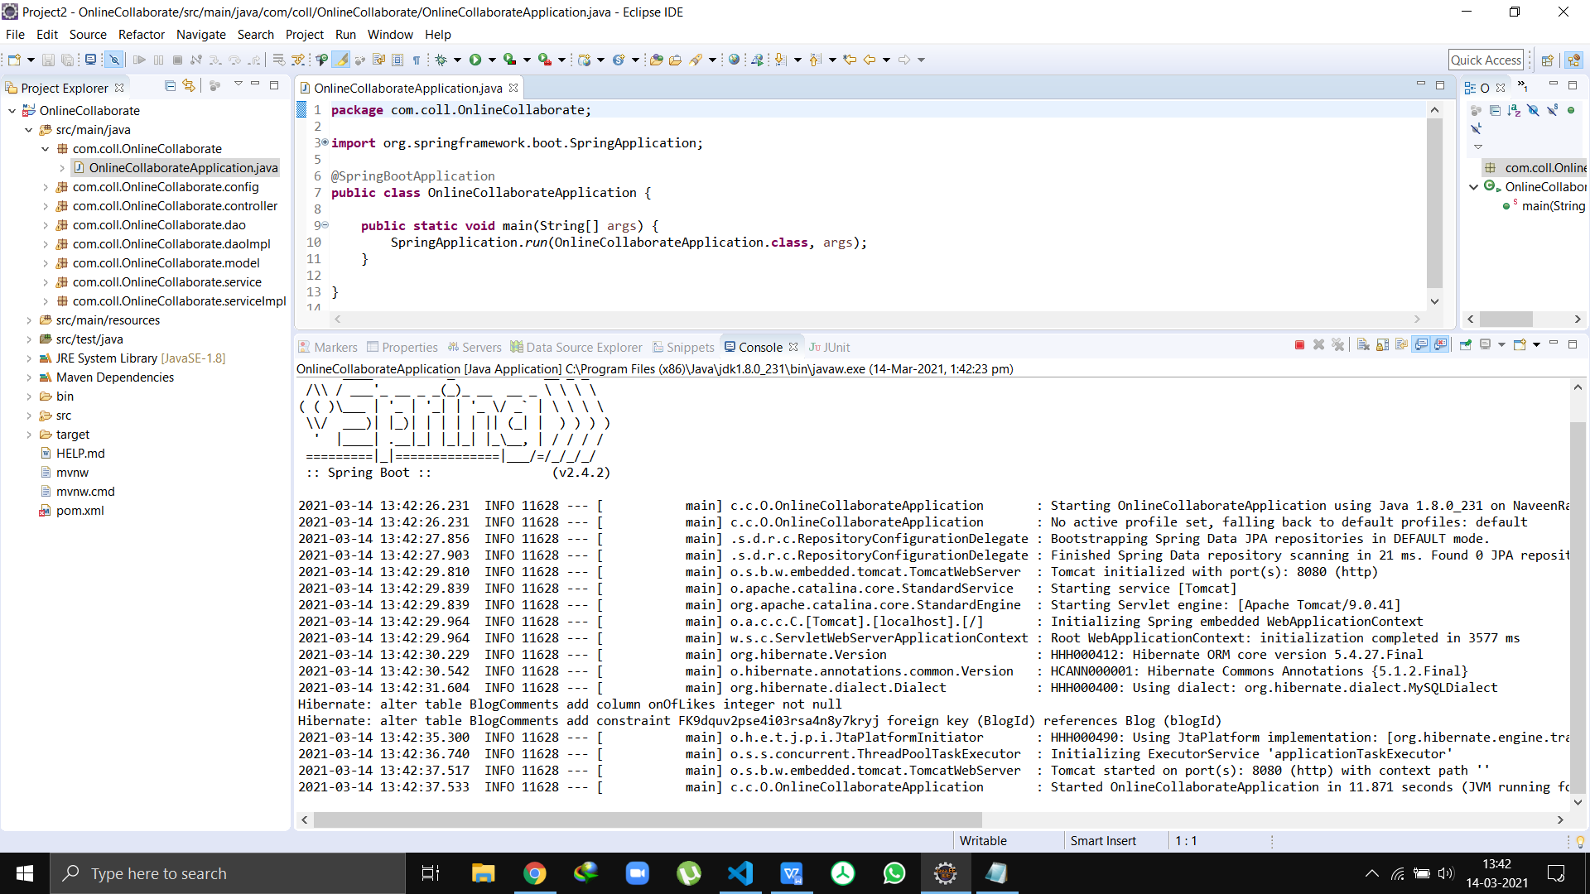

Starting the Angular

Run the cmd - ng serve --open

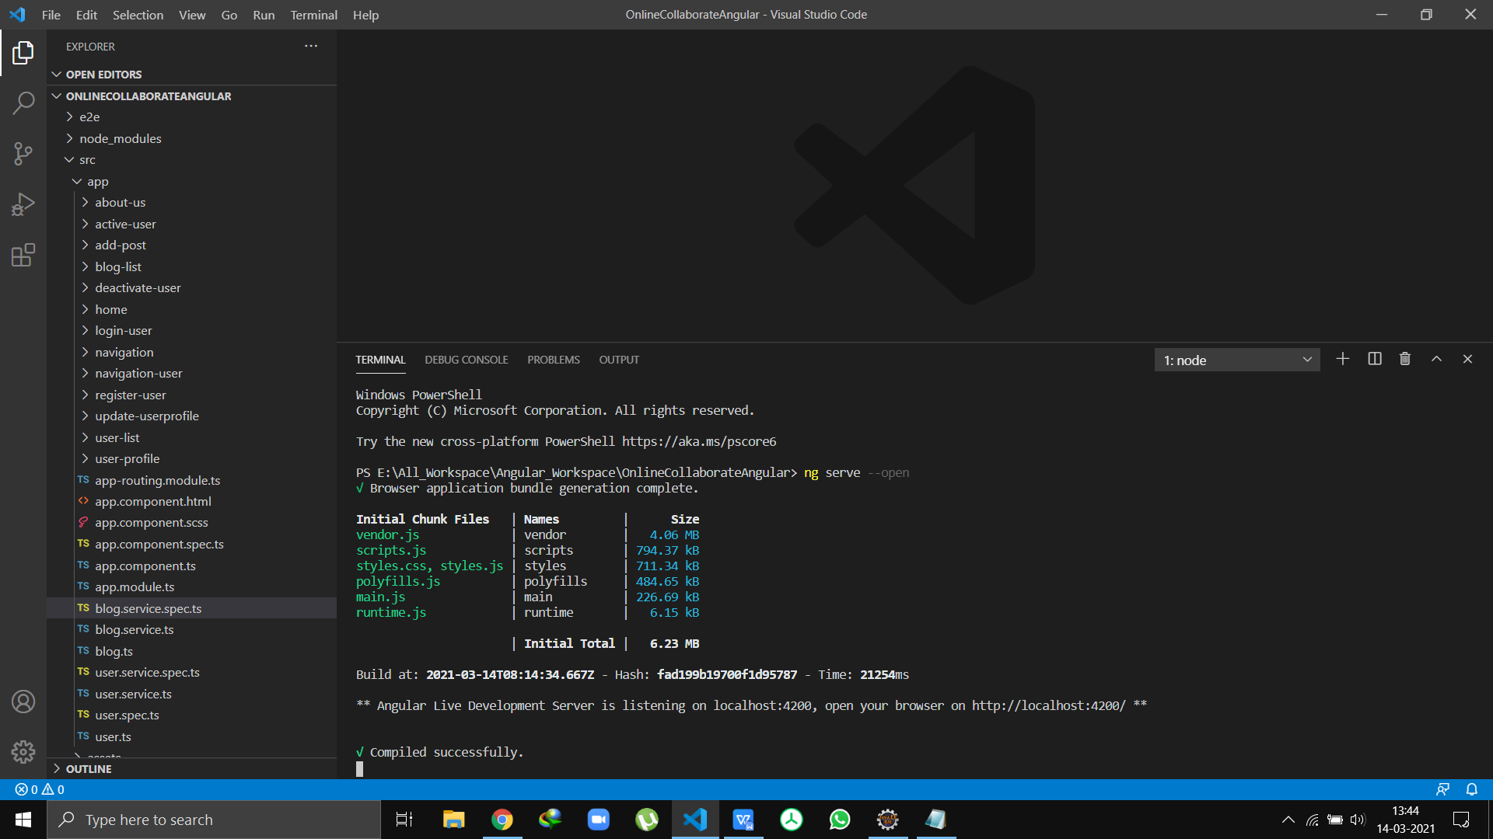

Home Page

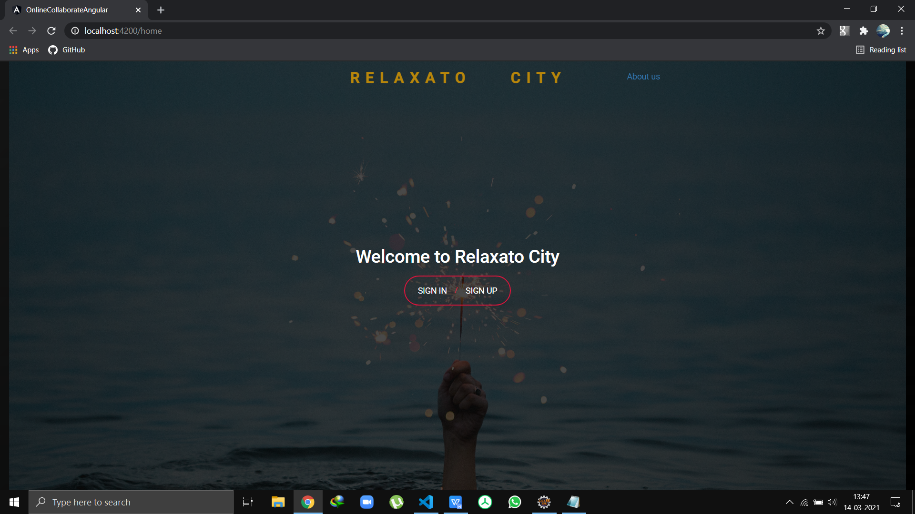

Login Page

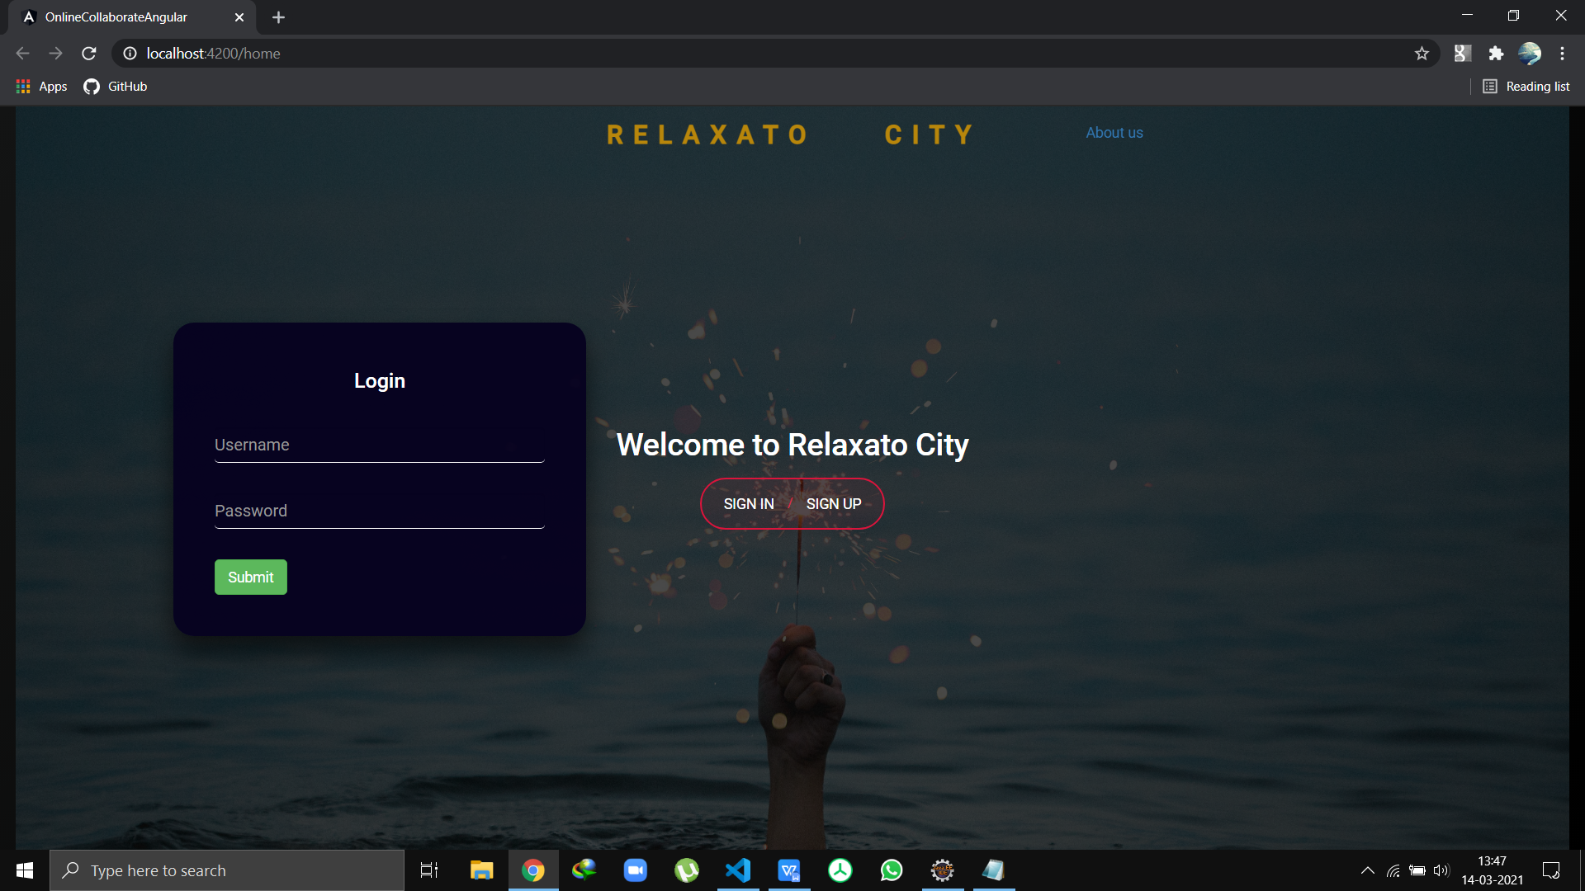

Registration Page

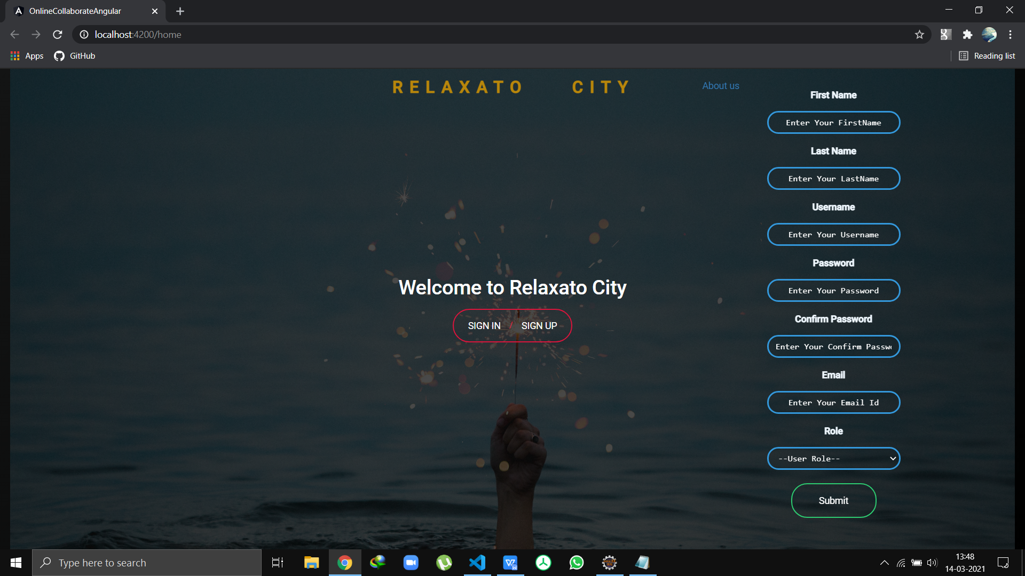

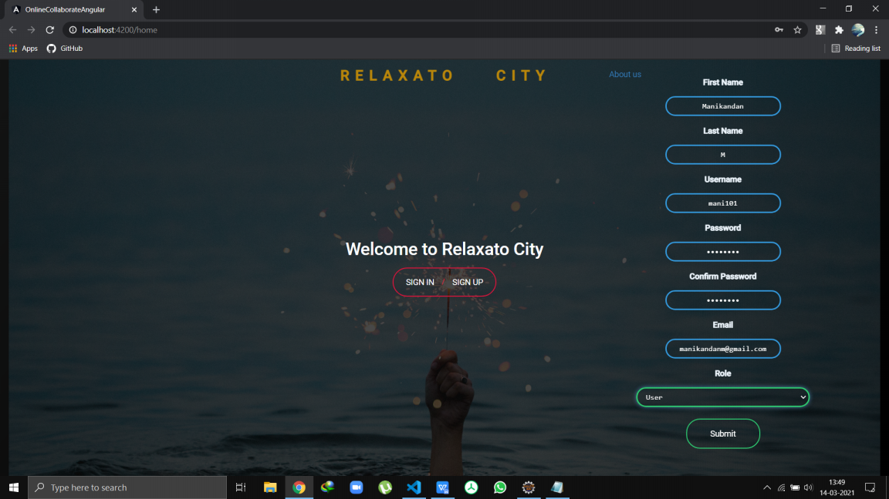

**Registration Success**

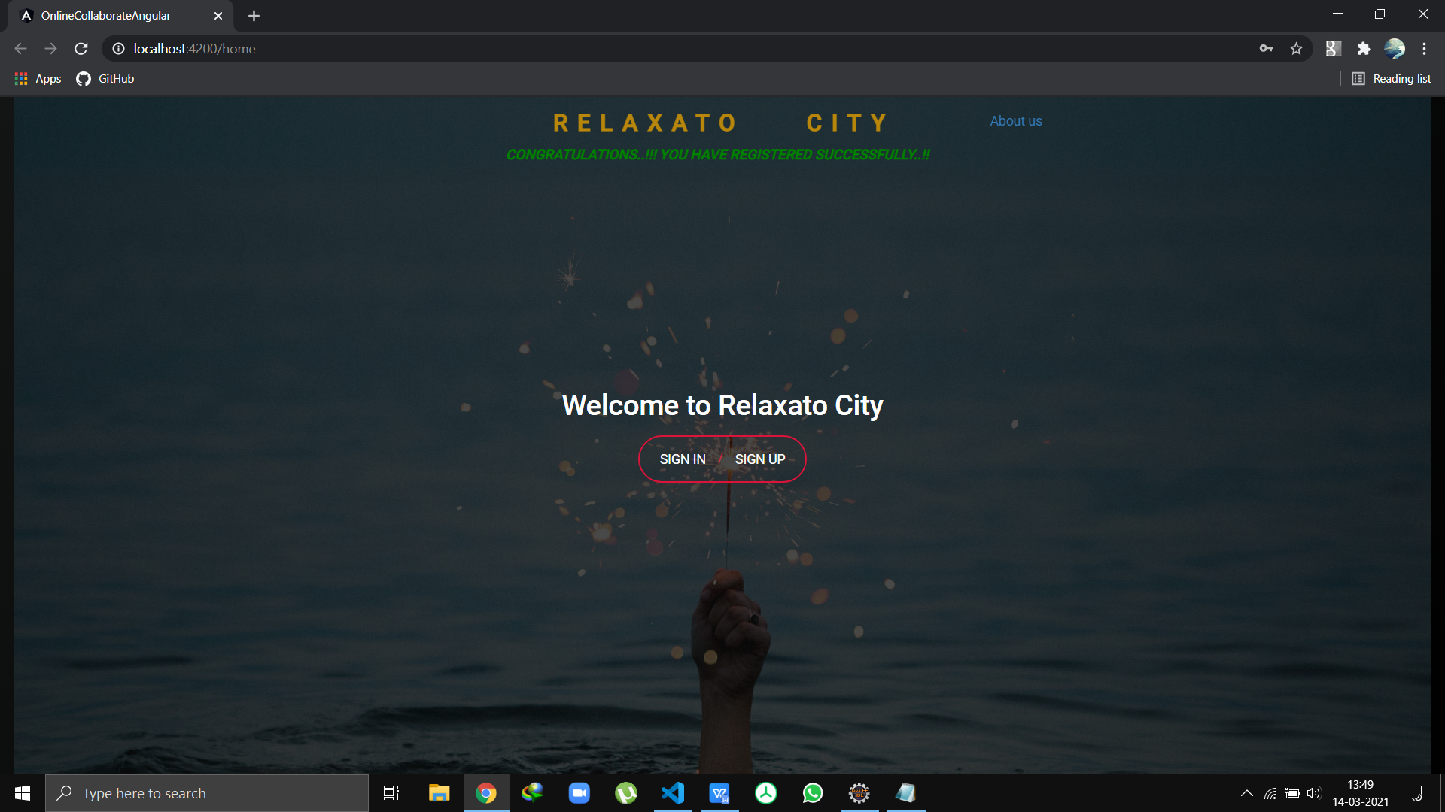

**Admin Login**

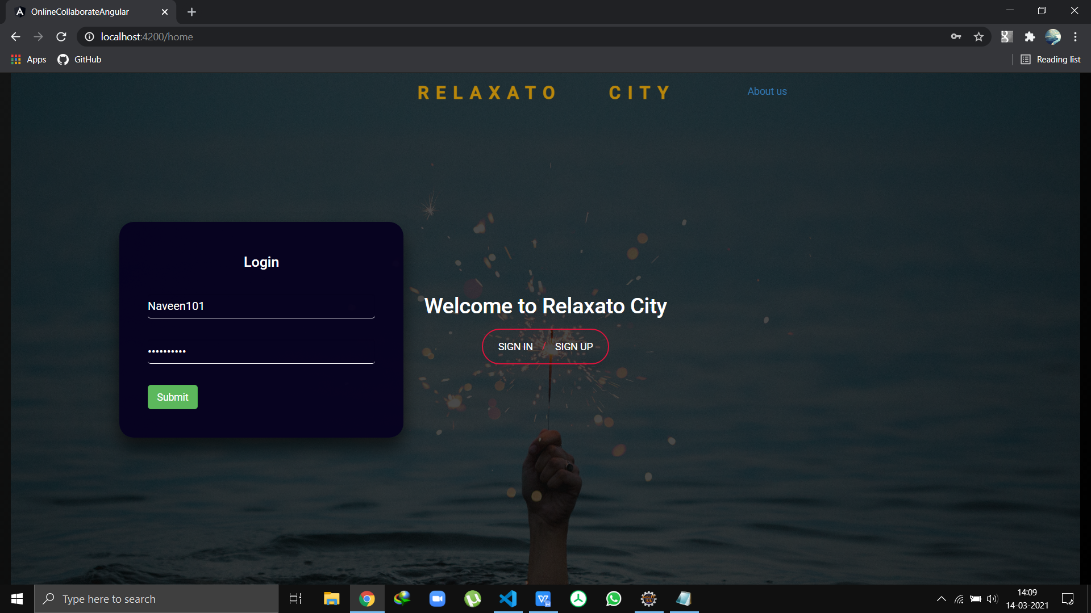

Admin Home

Profile

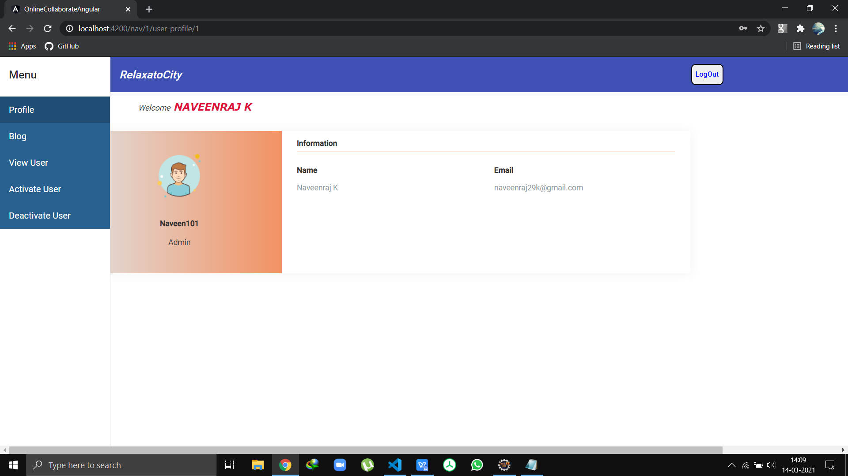

View User List

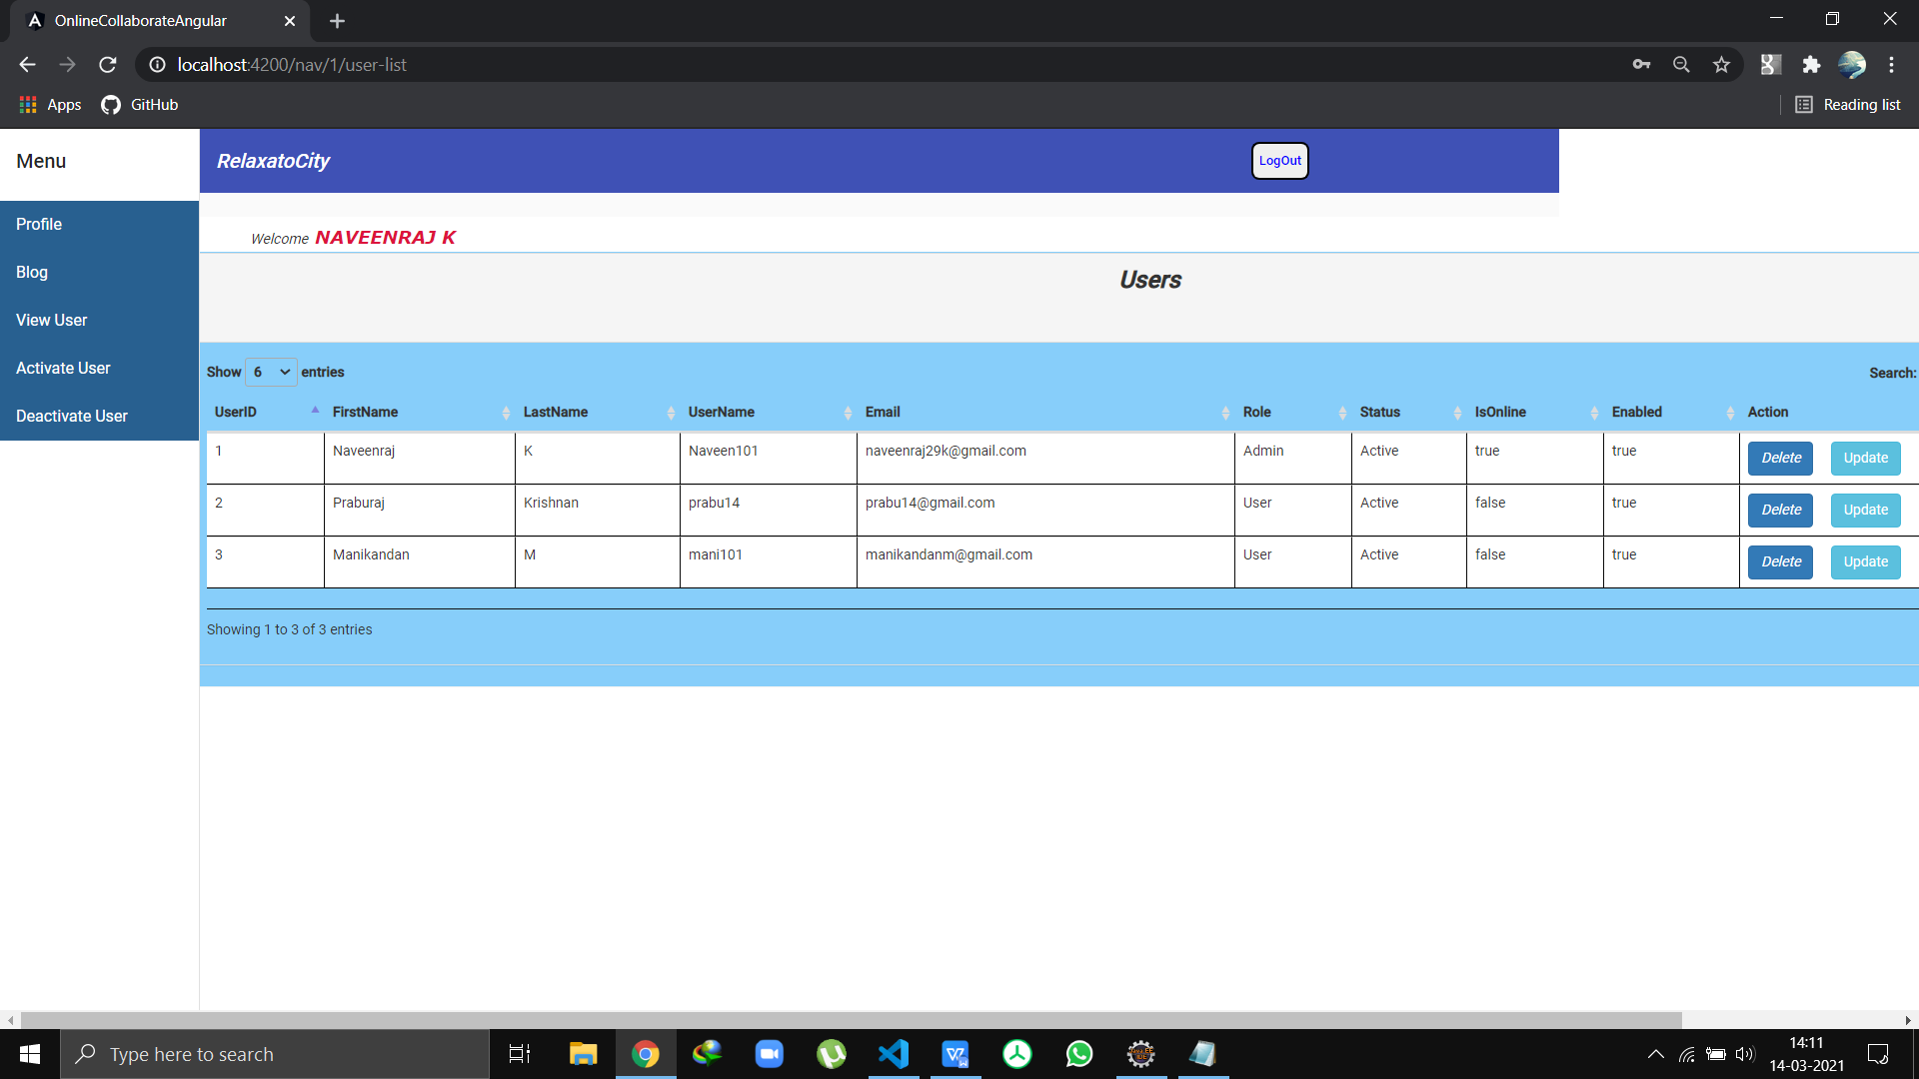

Users Deactive List

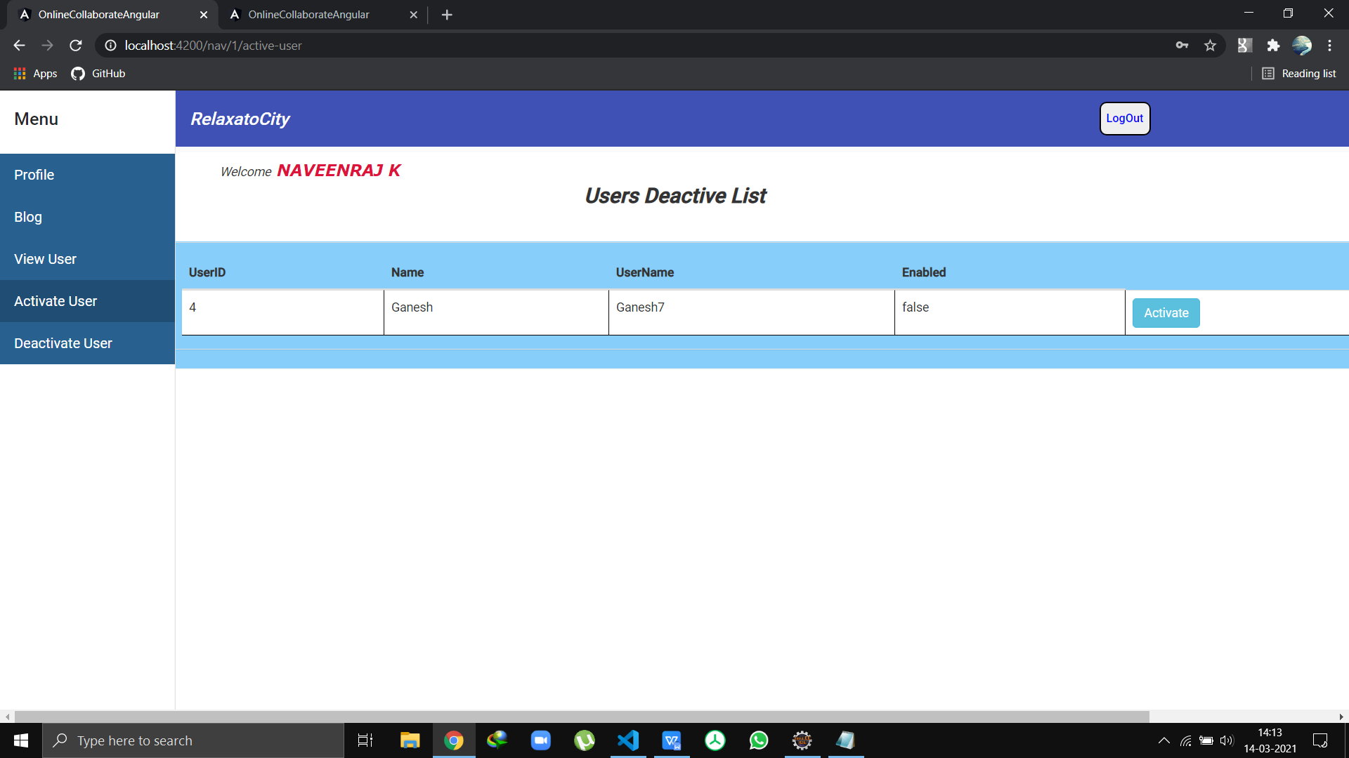Users Active List

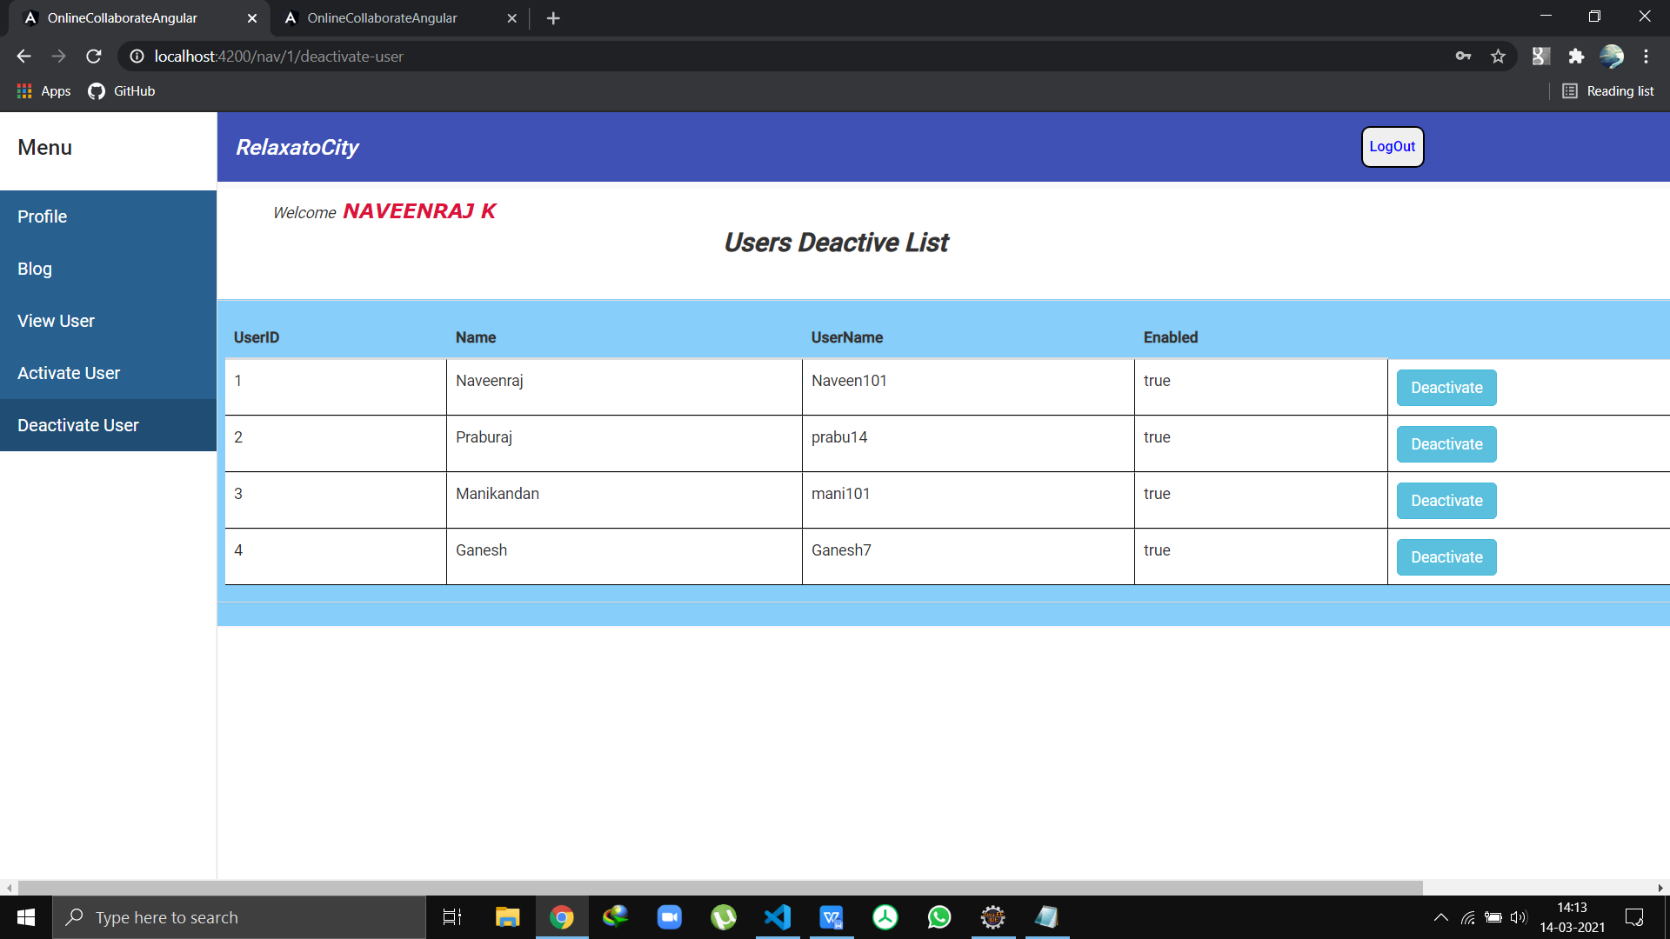

User Home

User Profile

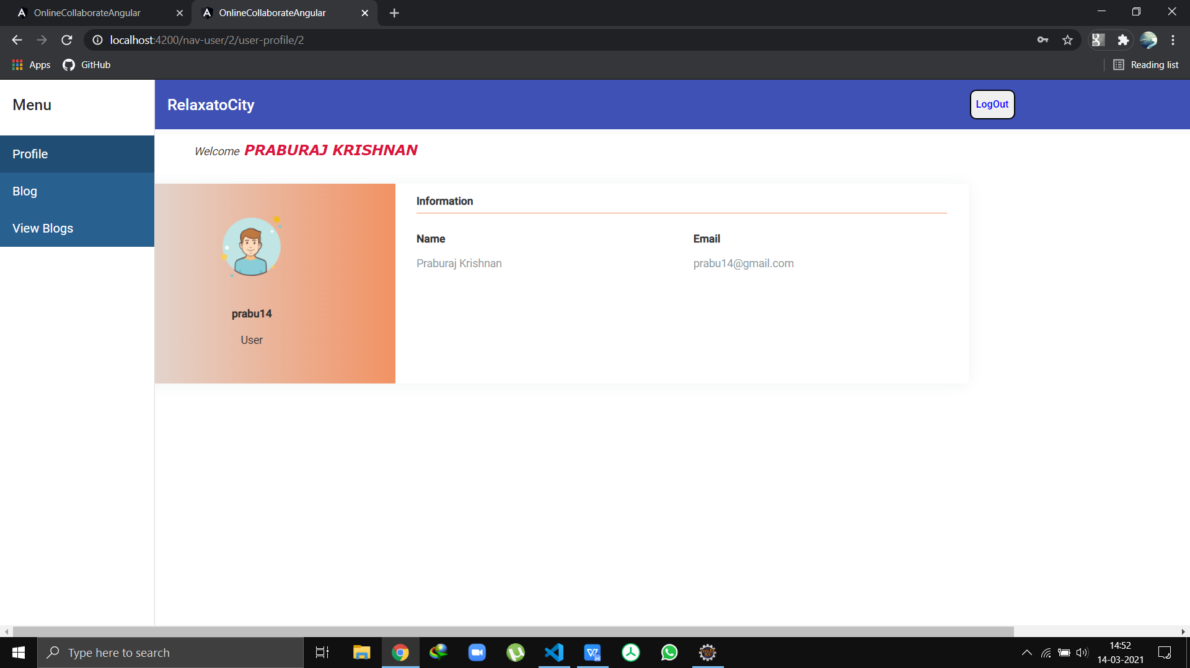

Blog

